MODEL PAPER = I
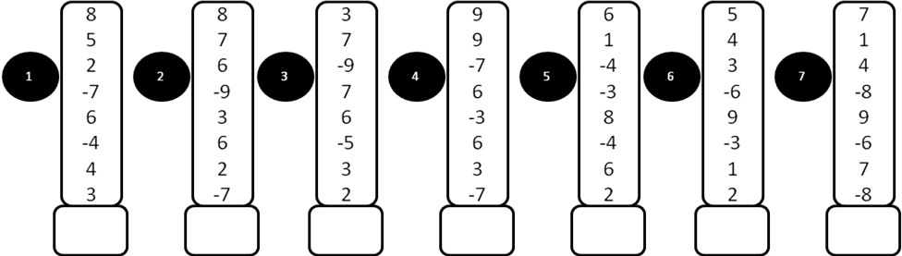
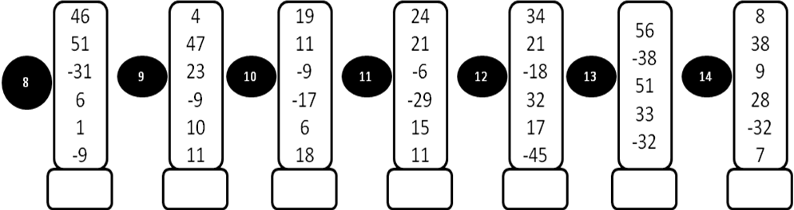
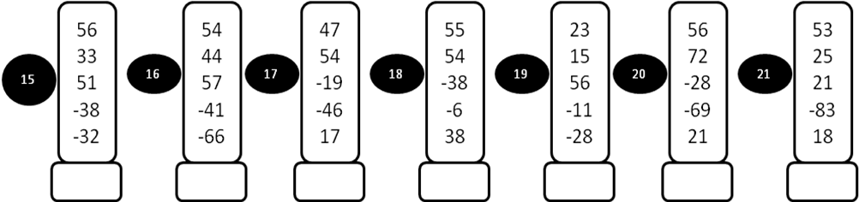
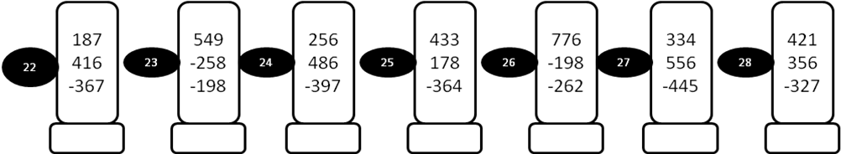
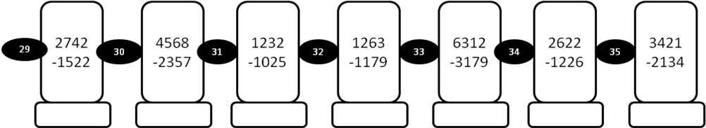
MODEL PAPER = I
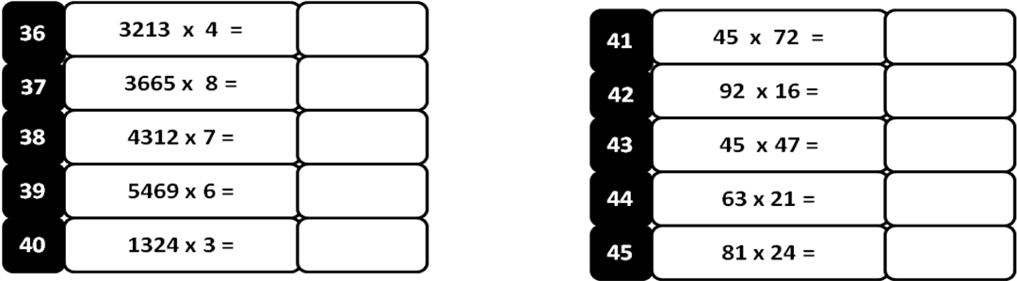
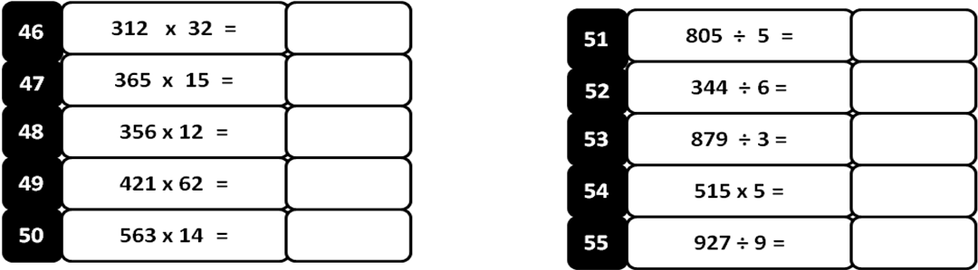
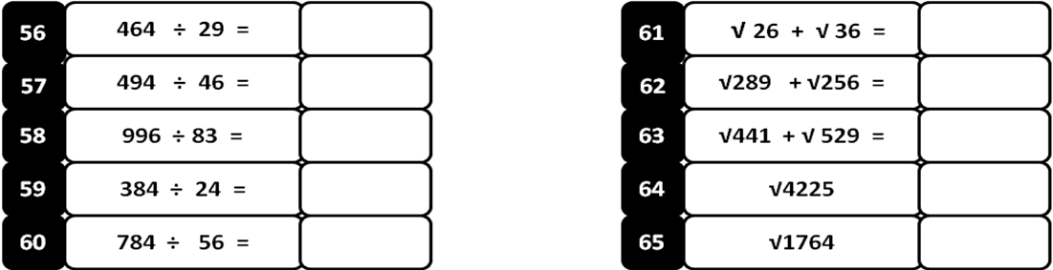
Write 63 counts

MODEL PAPER = II
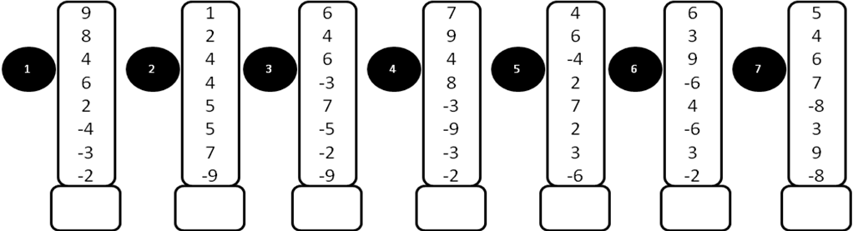
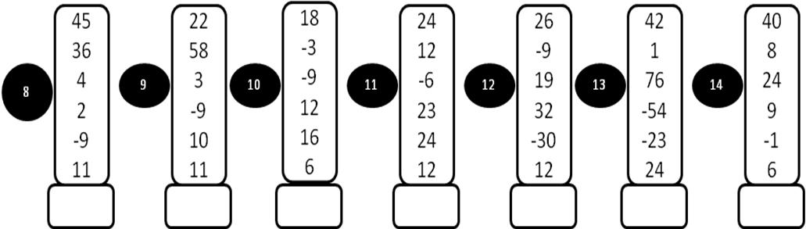
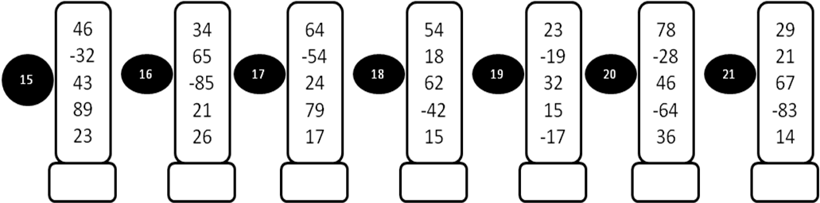
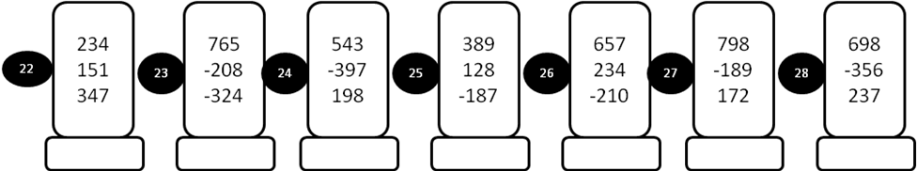
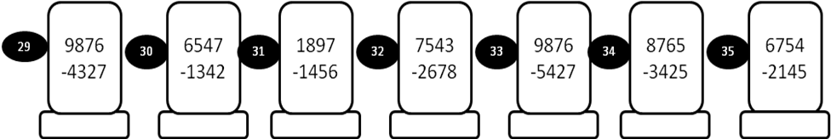
MODEL PAPER = II
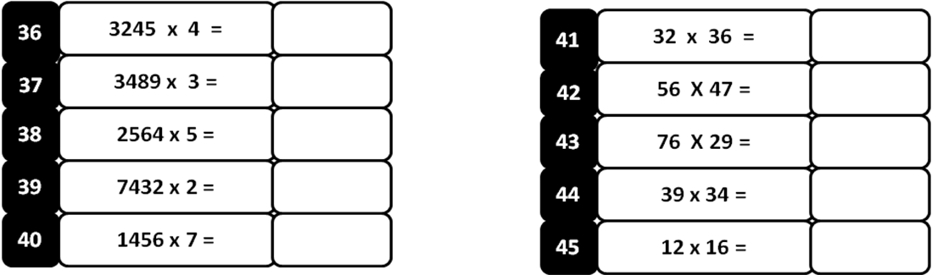

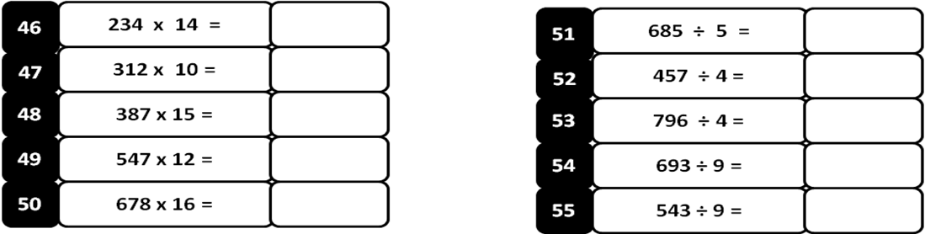

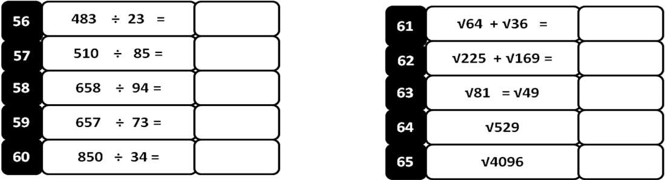

Write 84 counts
MODEL PAPER = III
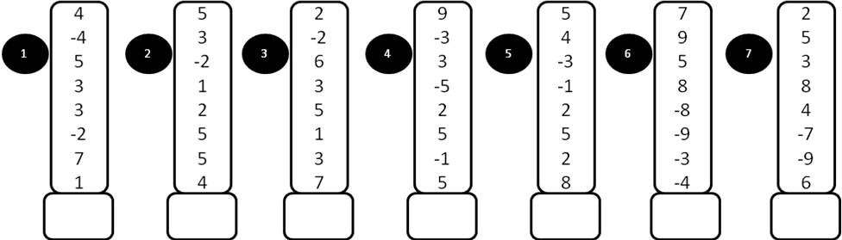
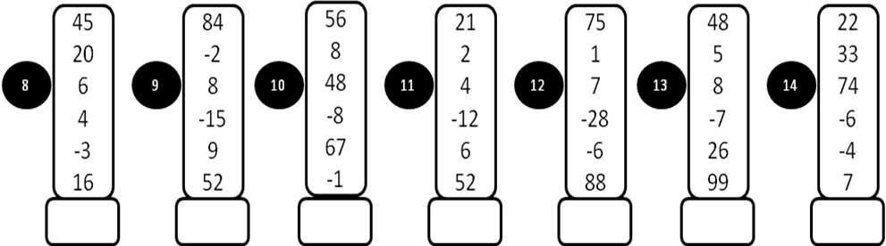

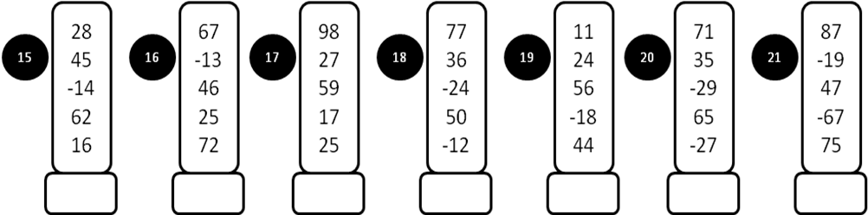

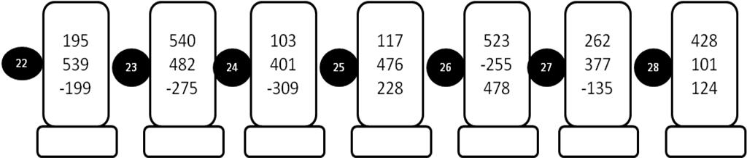

MODEL PAPER = III
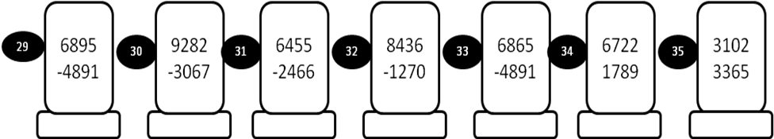
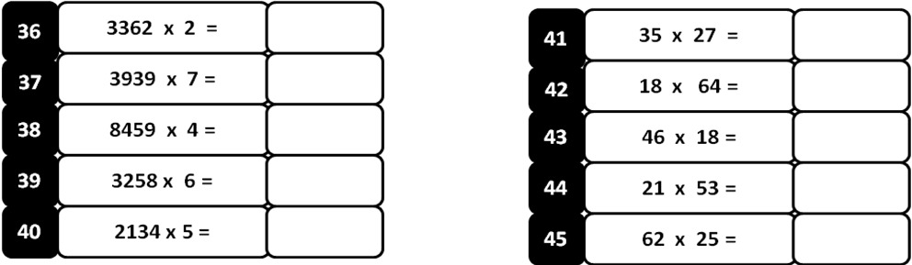
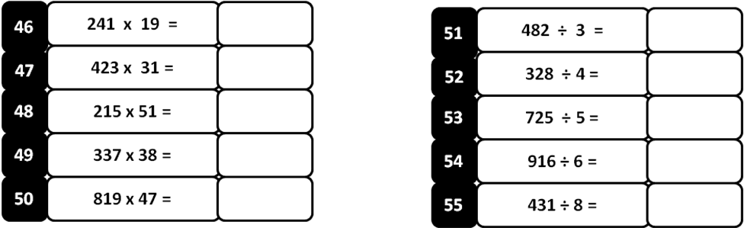
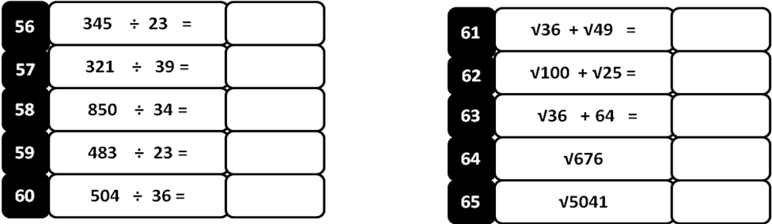
Write 73 counts:

