MODEL PAPER = I
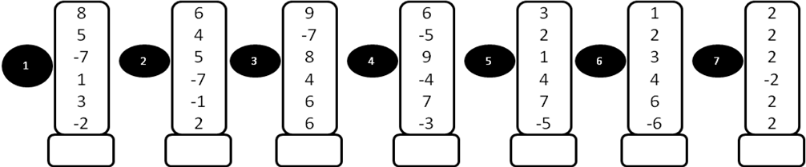
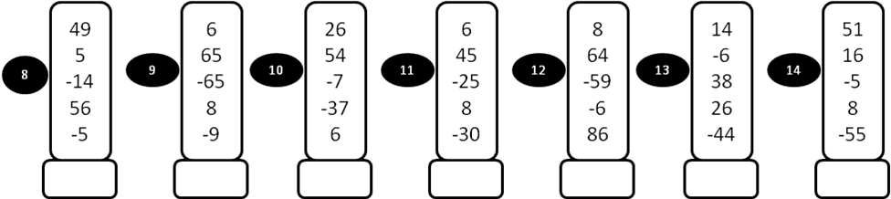

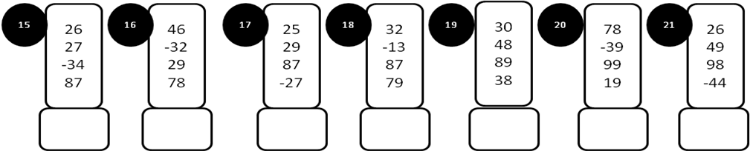

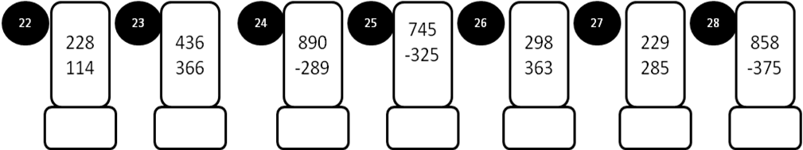

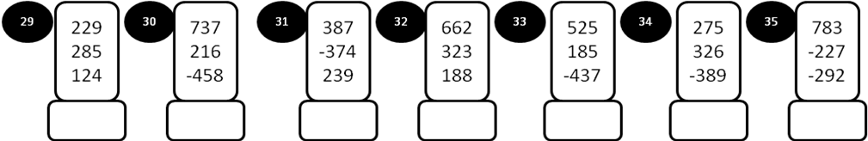
MODEL PAPER = I

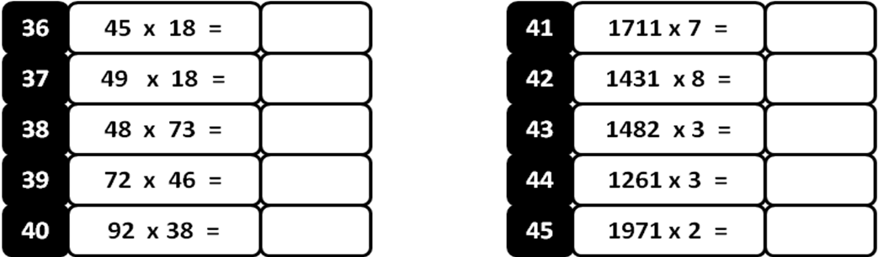
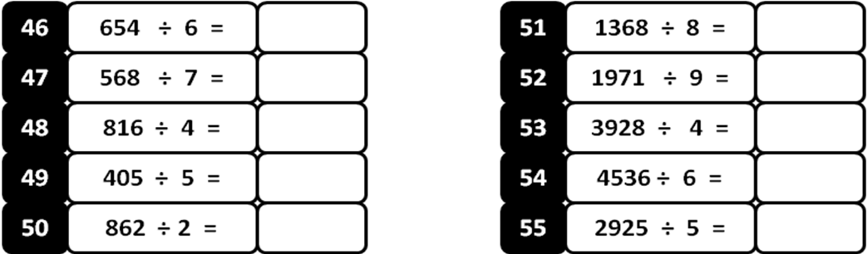
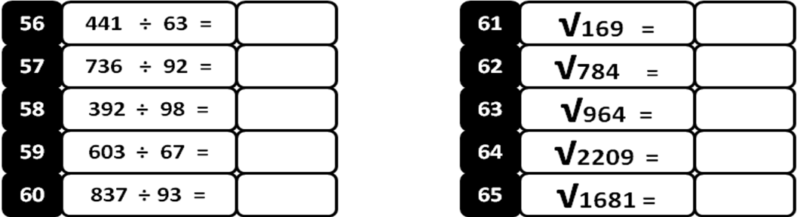

Write 47 counts:

MODEL PAPER = II
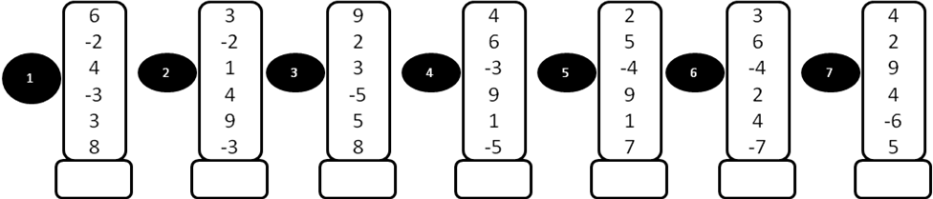

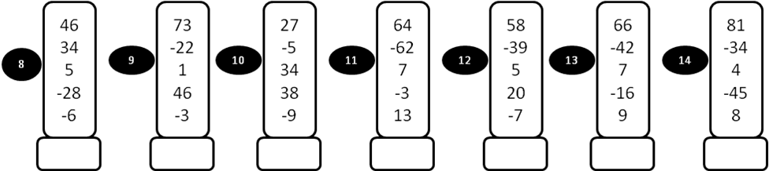
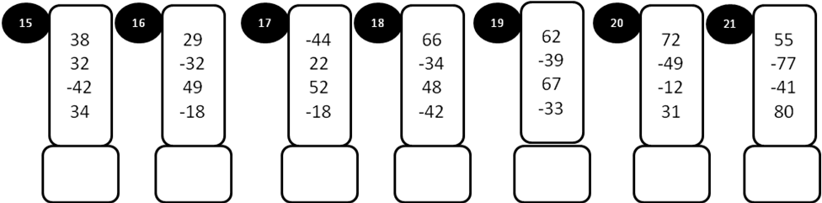

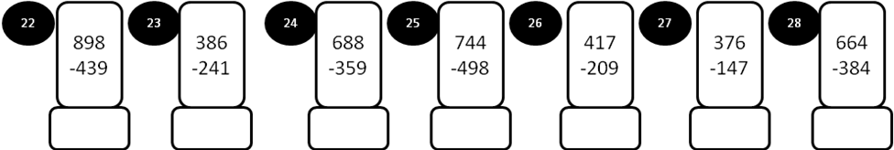
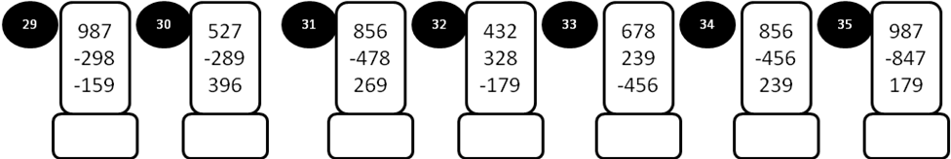
MODEL PAPER = II

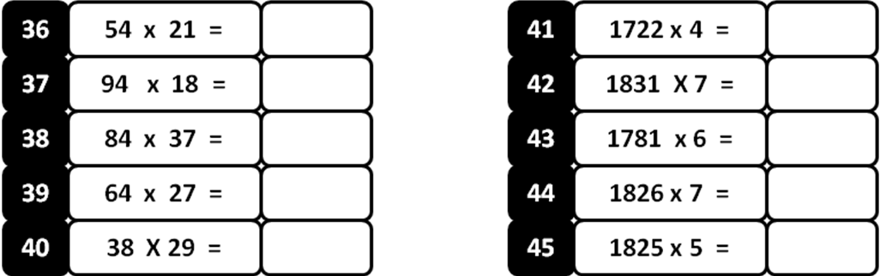
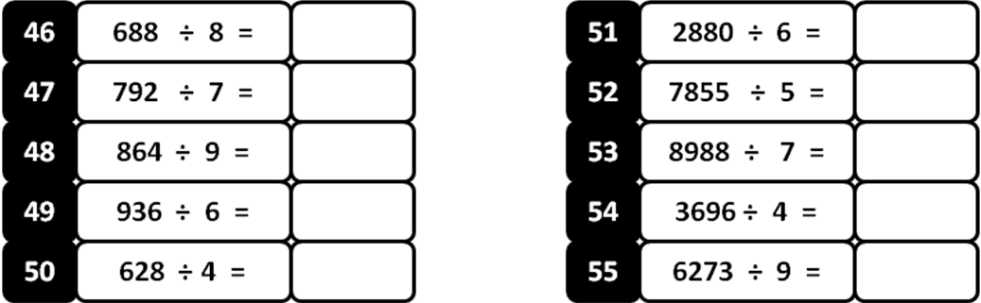
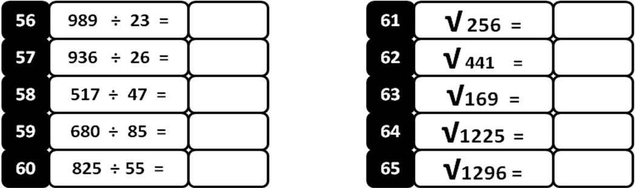
Write 68 counts:

MODEL PAPER =III

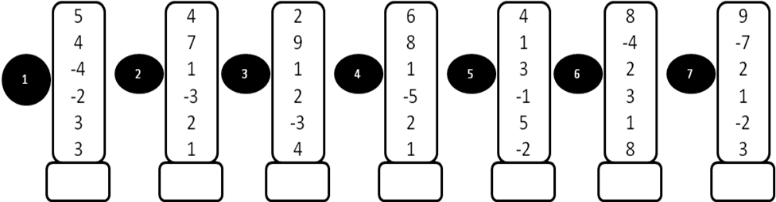
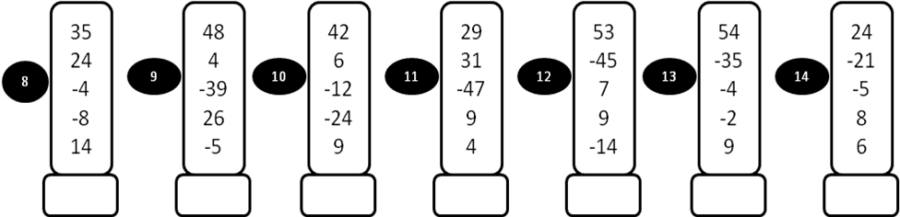
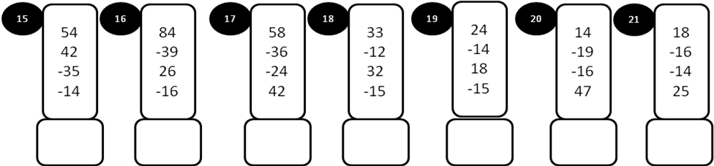
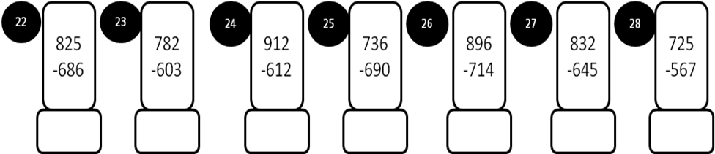
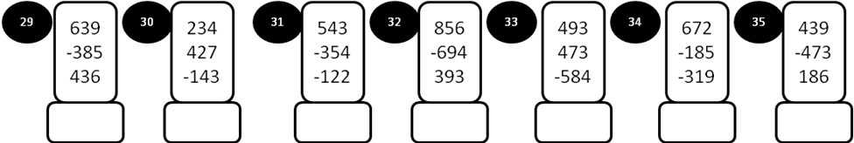
MODEL PAPER =III

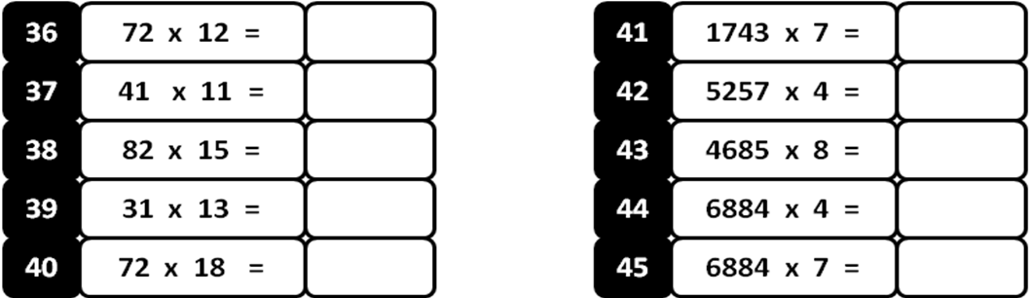
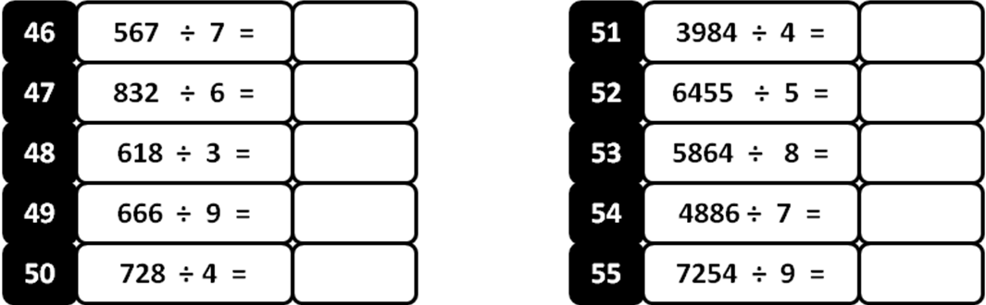
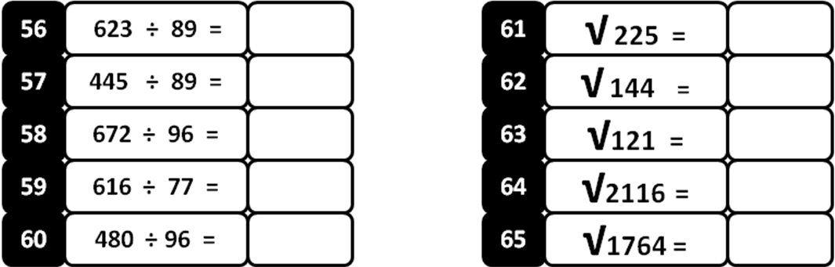

Write 56 counts
MODEL PAPER =IV

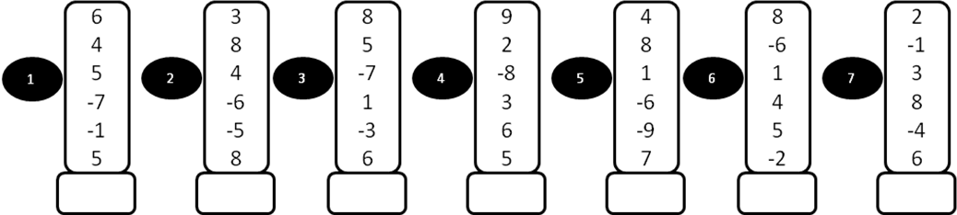
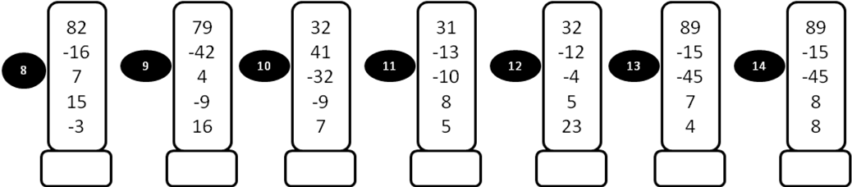
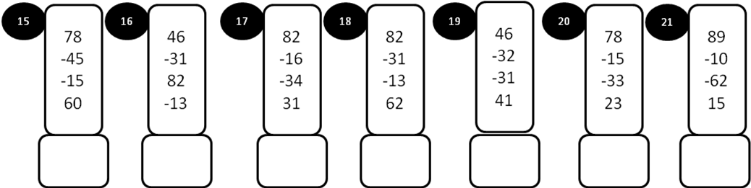
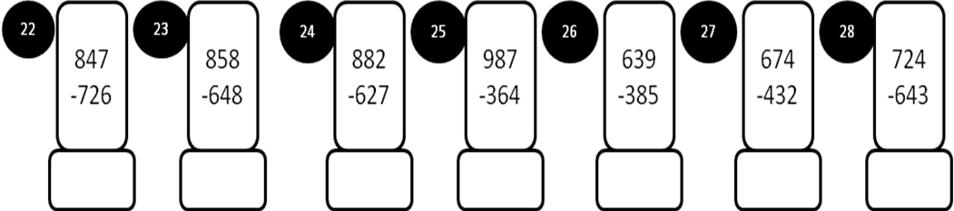
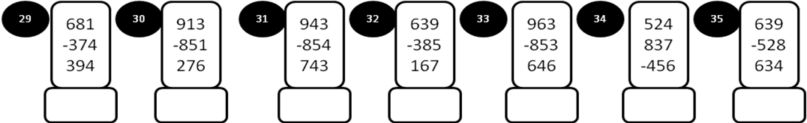
MODEL PAPER =IV

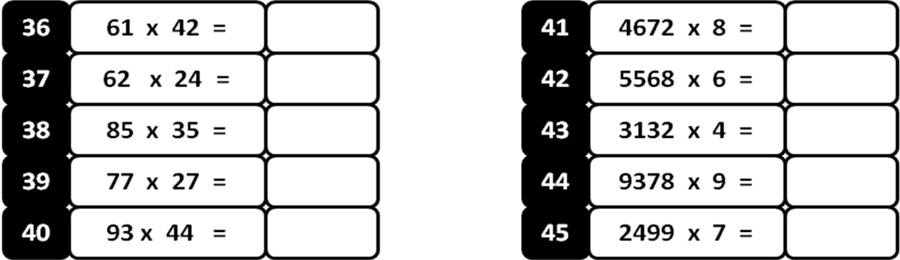
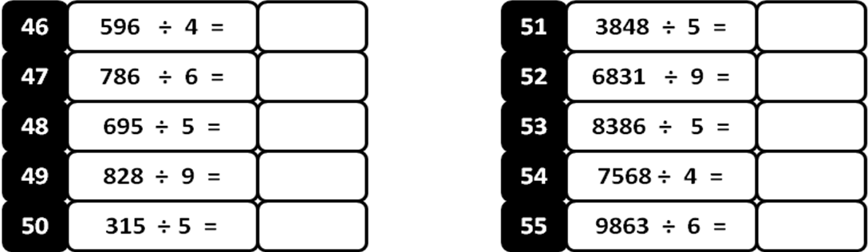
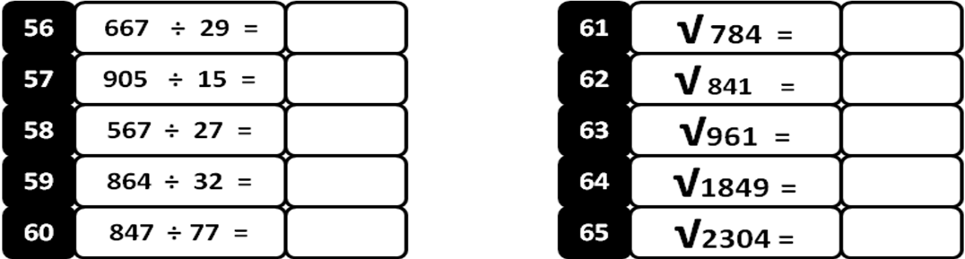

Write 81 Counts

