MODEL PAPER = I
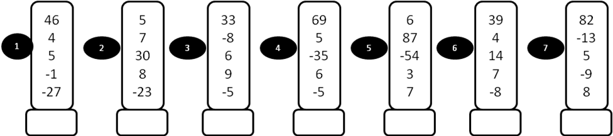
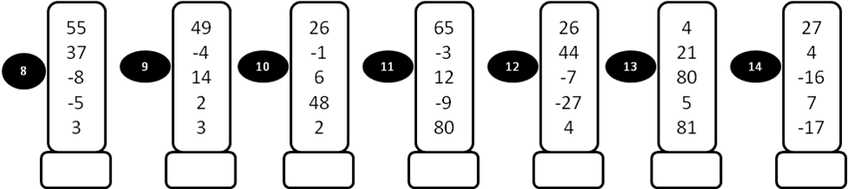

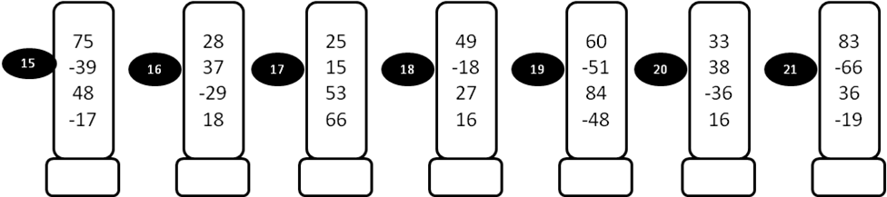

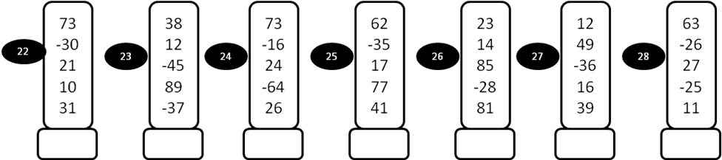
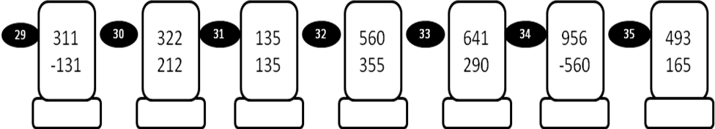
MODEL PAPER = I
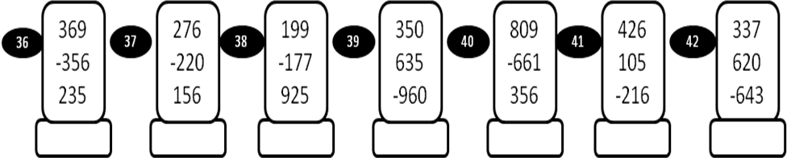

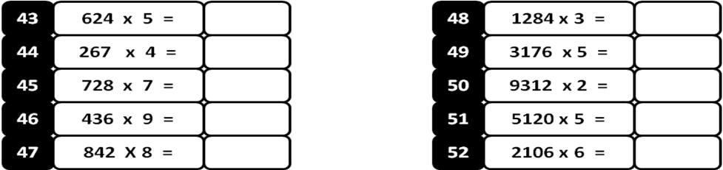

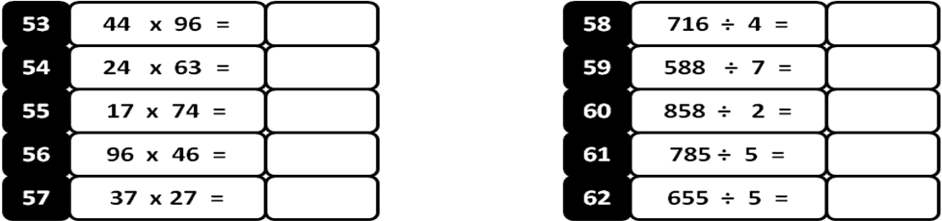

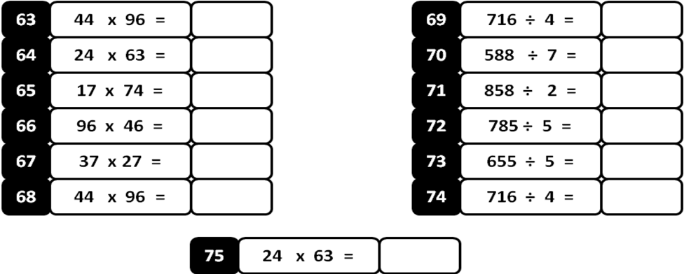
MODEL PAPER = II
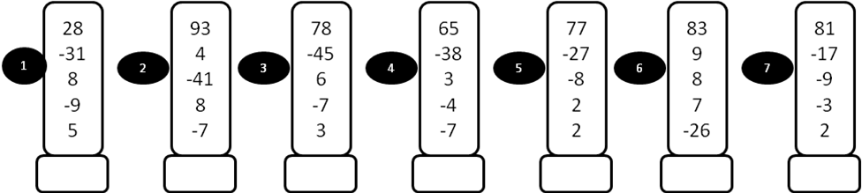
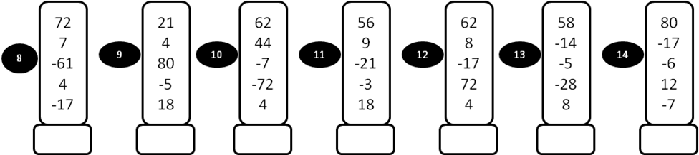
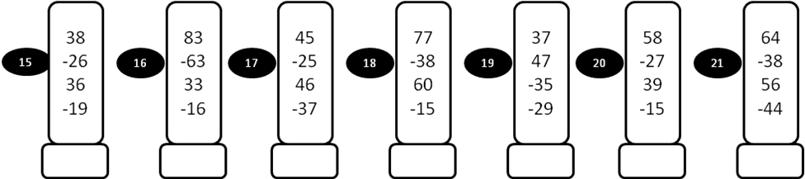
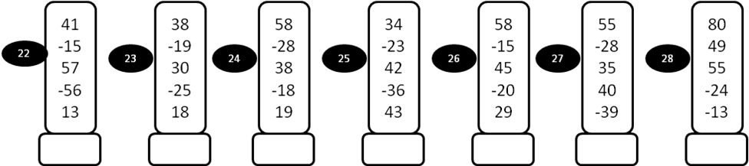

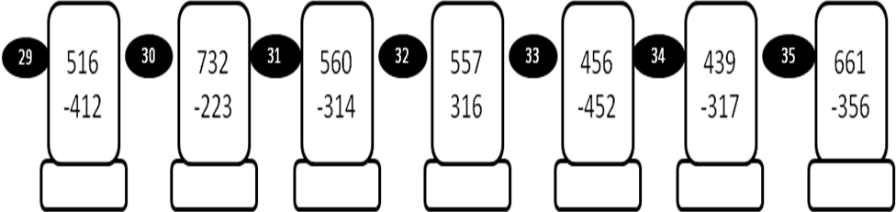
MODEL PAPER = II

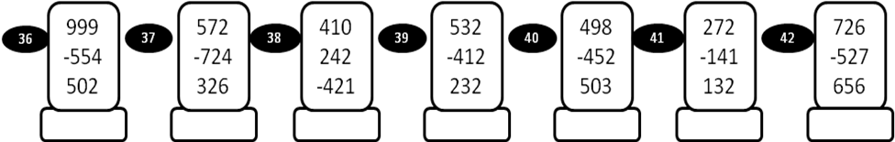
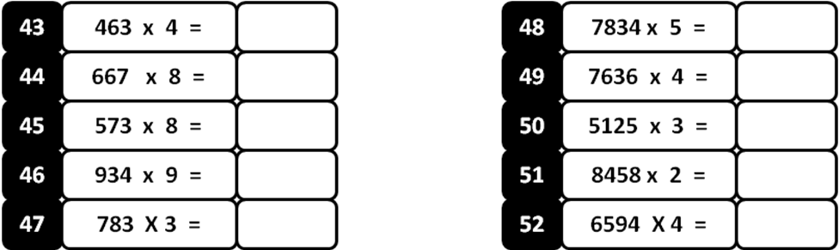
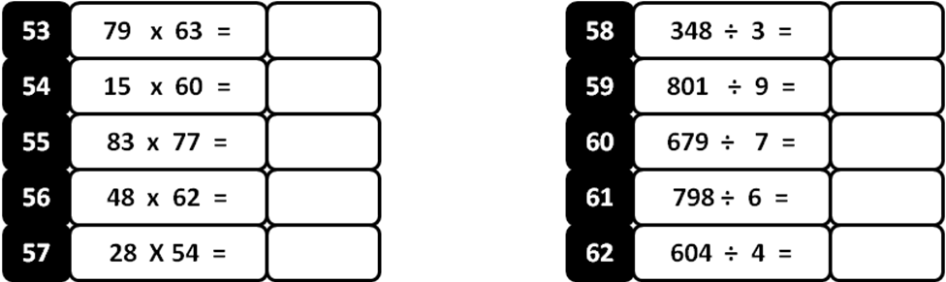
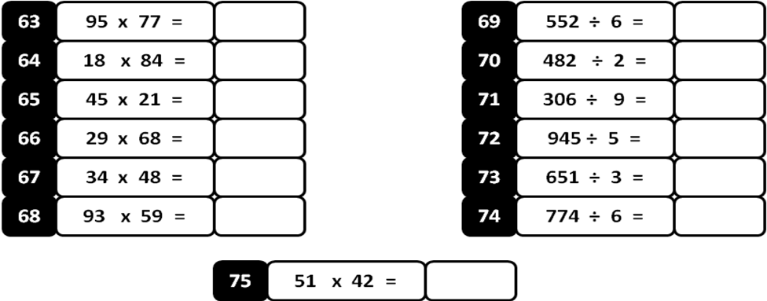
MODEL PAPER = III
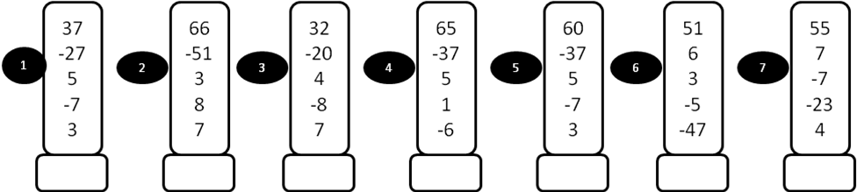
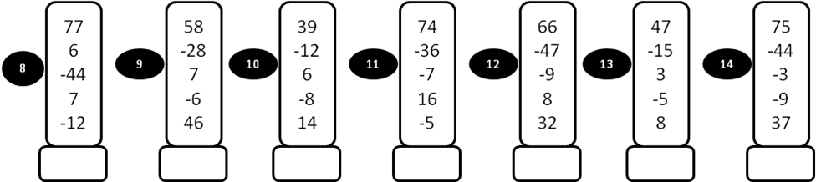
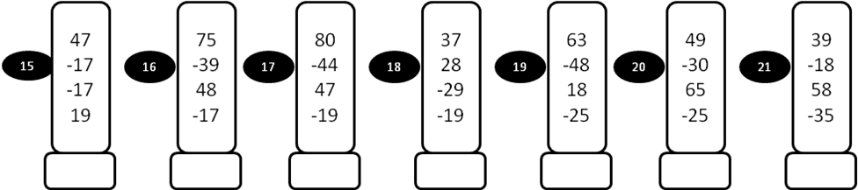
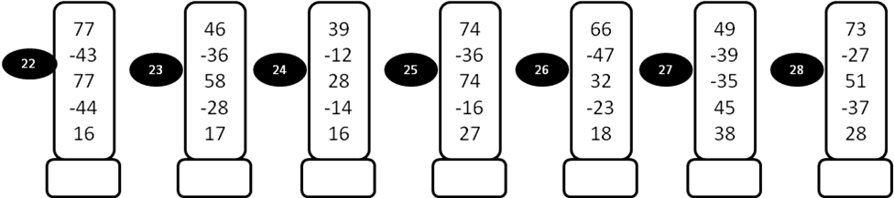

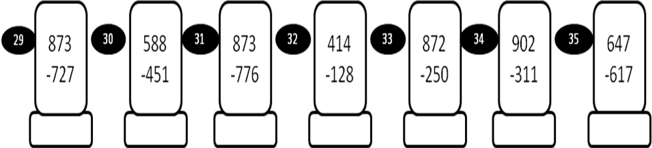
MODEL PAPER = III
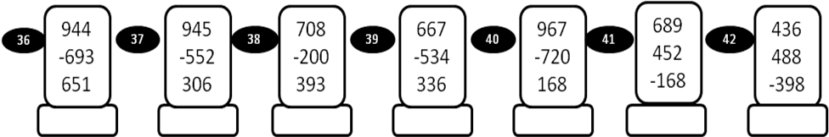
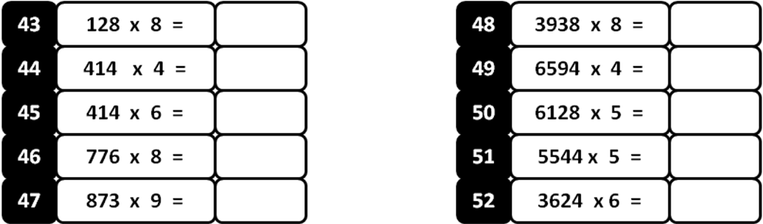
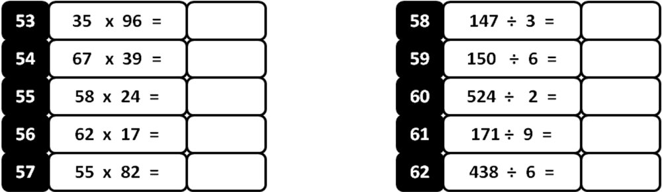

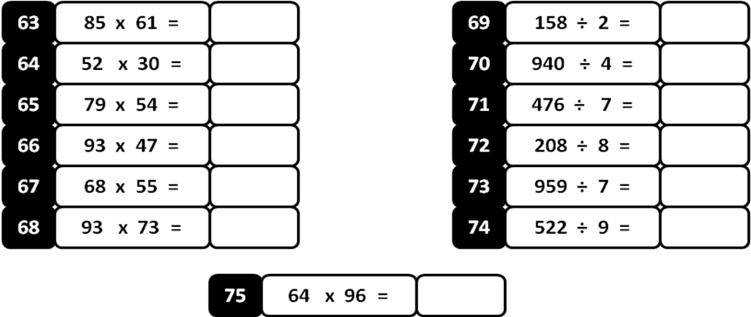
MODEL PAPER =IV
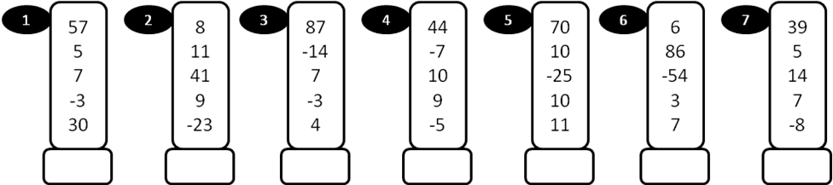
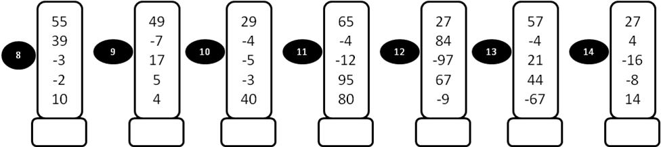
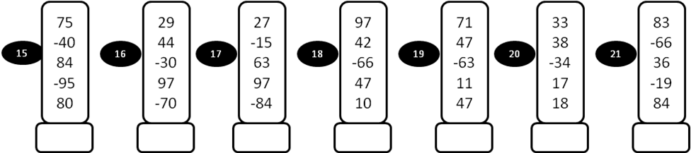
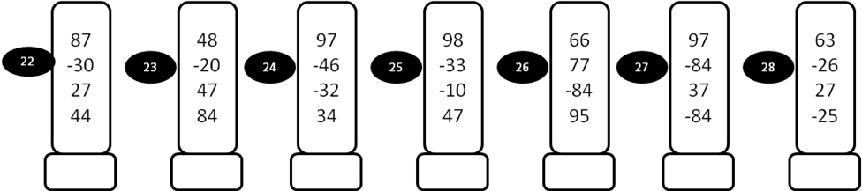

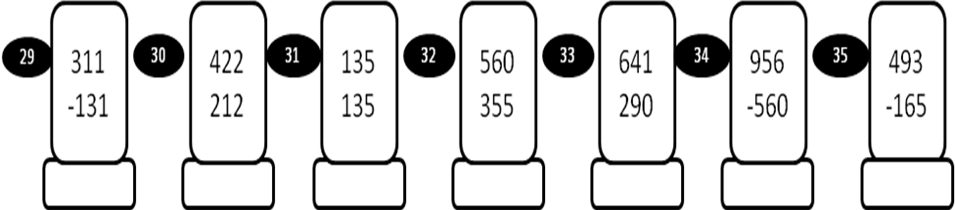
MODEL PAPER = IV
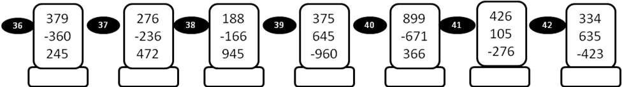
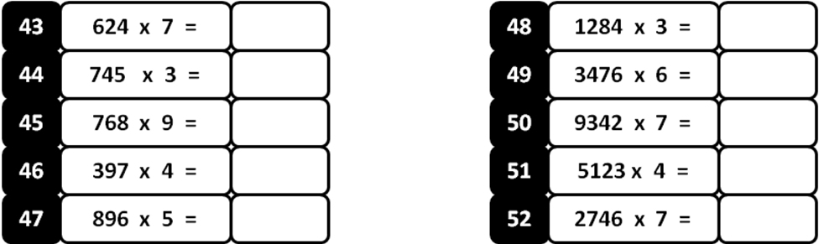
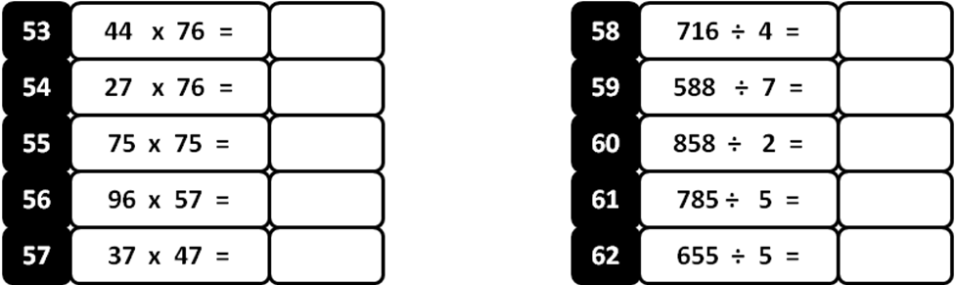
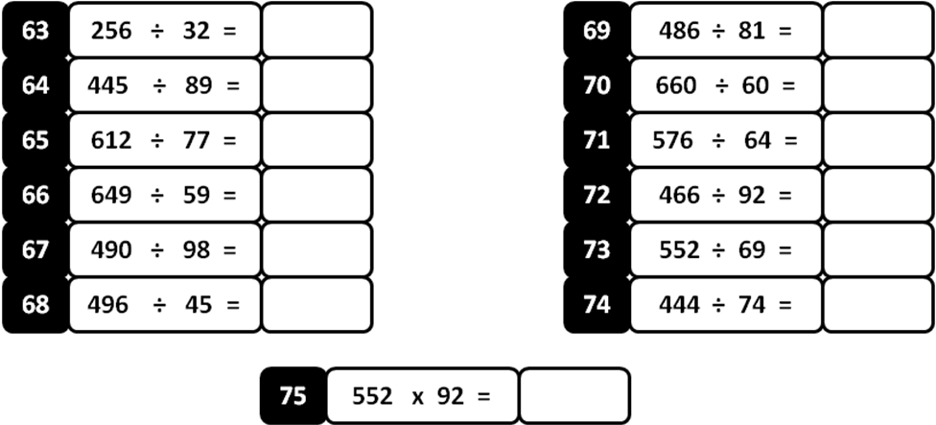

MODEL PAPER =V
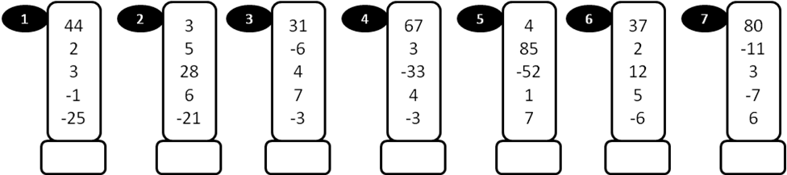
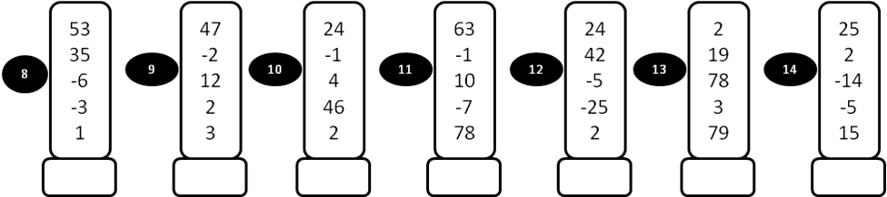
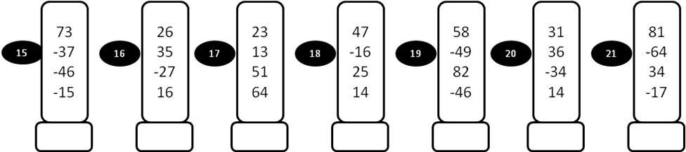
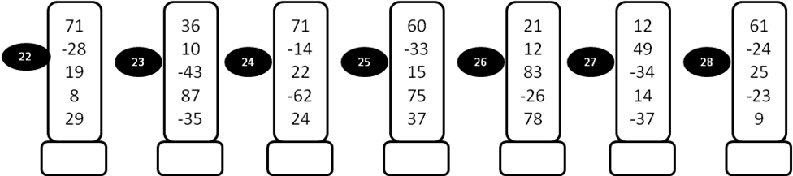

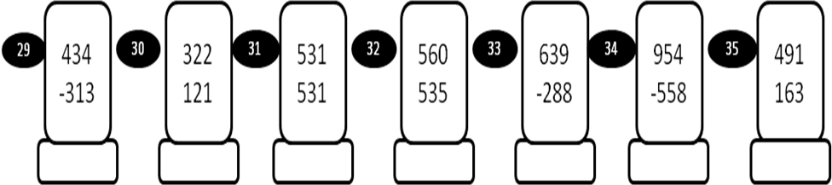
MODEL PAPER =V
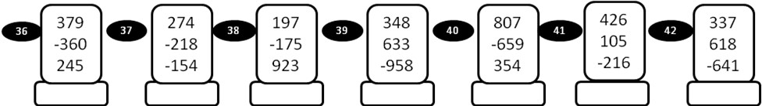
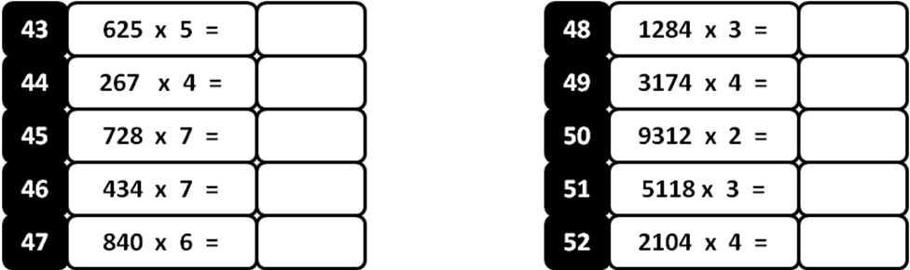
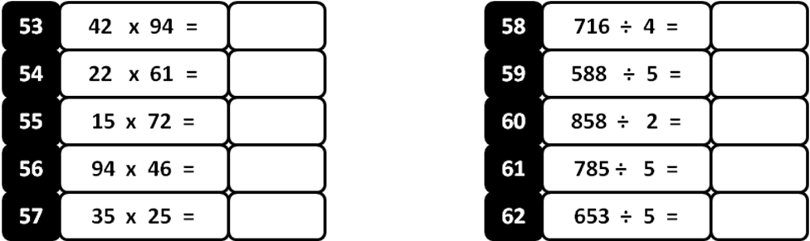
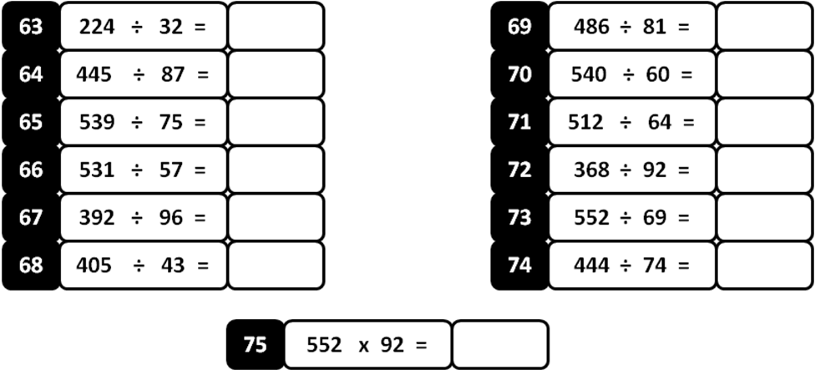

MODEL PAPER =VI

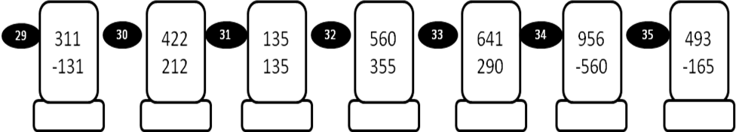

MODEL PAPER =VI

MODEL PAPER = VII

MODEL PAPER =VII

