MODEL PAPER=I

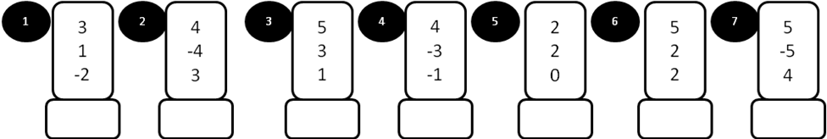

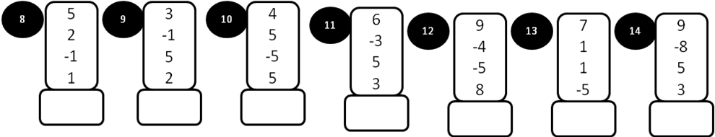

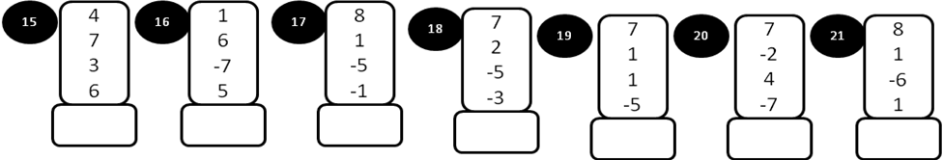

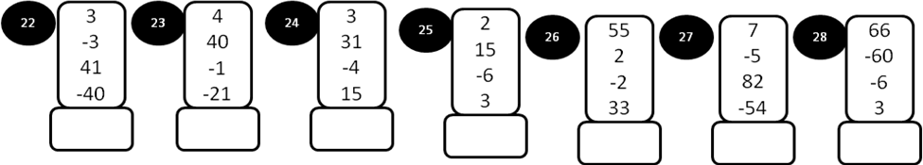

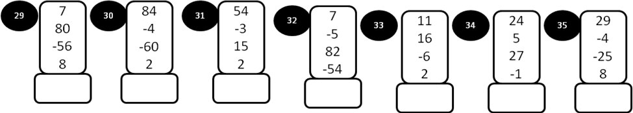
MODEL PAPER =I

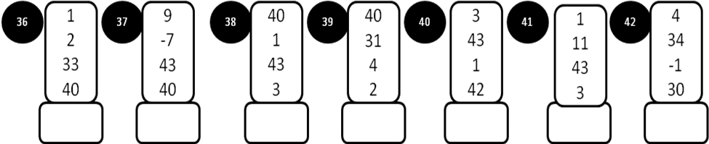
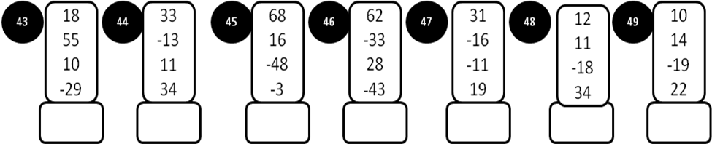
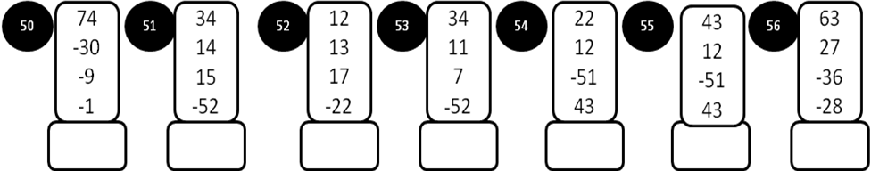
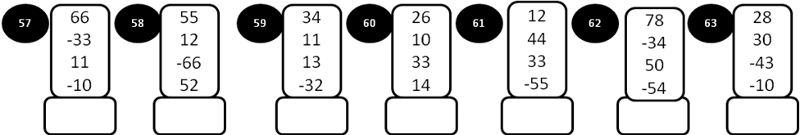

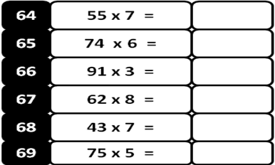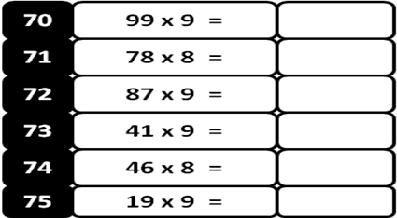

MODEL PAPER =II

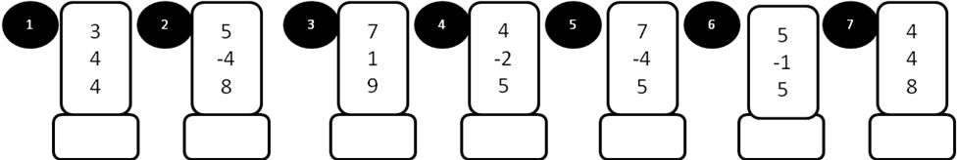

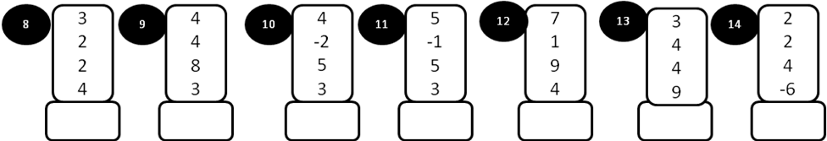

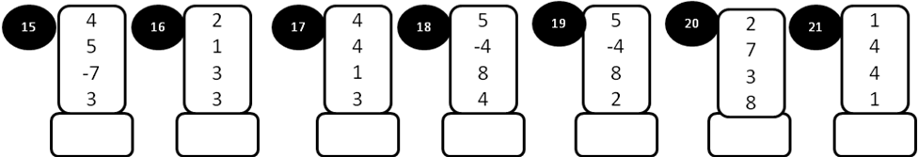

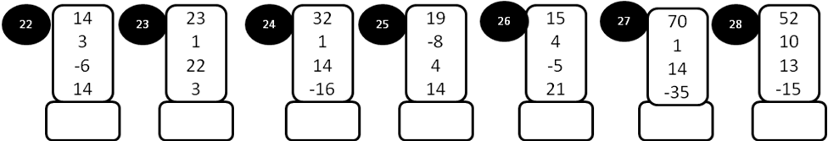

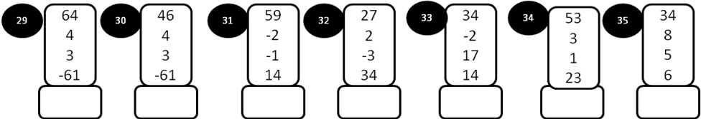
MODEL PAPER=II

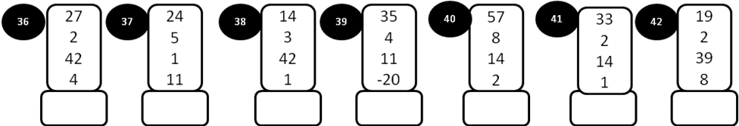

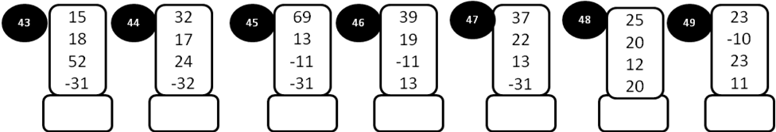

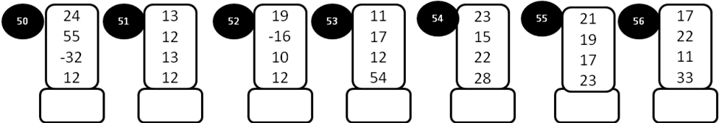
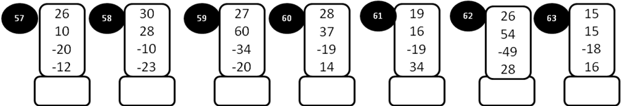

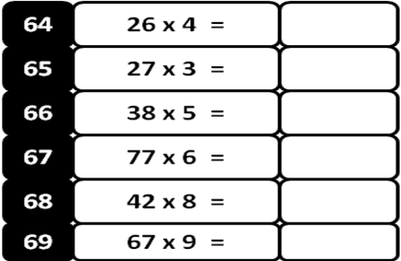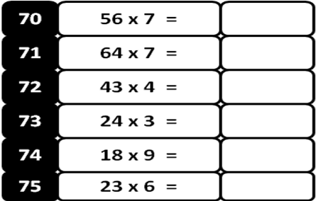
MODEL PAPER = III
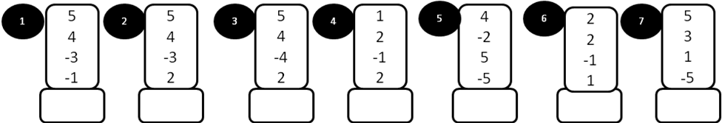

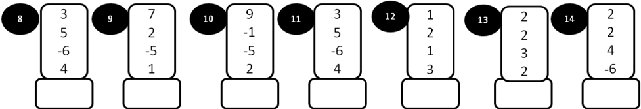

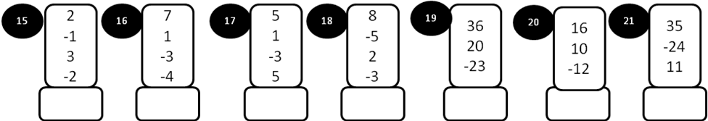

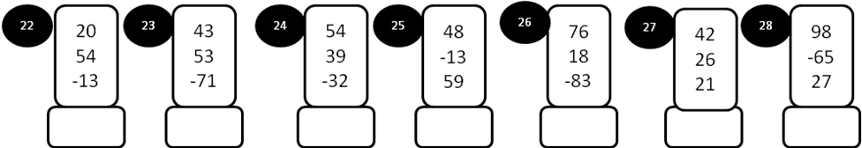

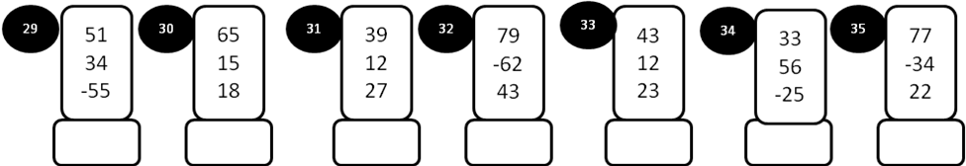

MODEL PAPER = III
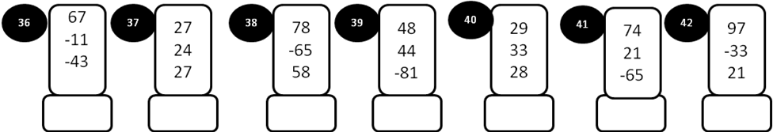

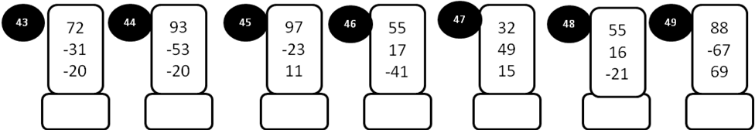

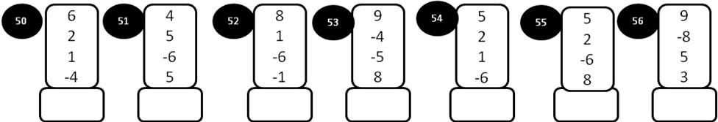

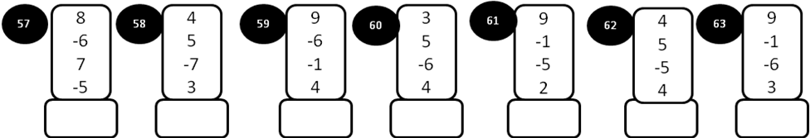

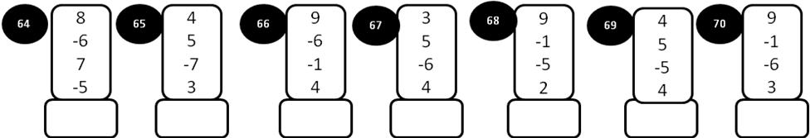

MODEL PAPER =IV

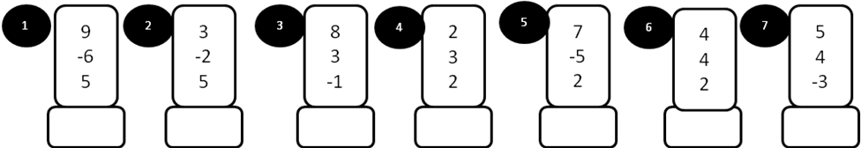

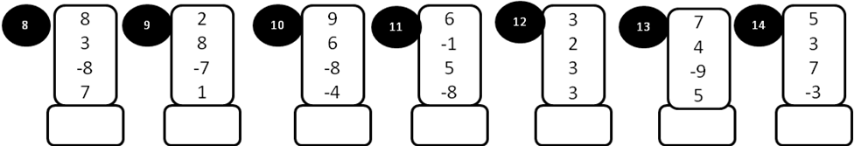

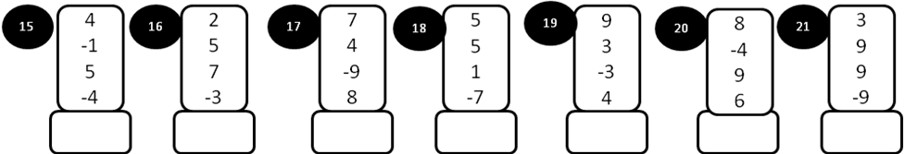

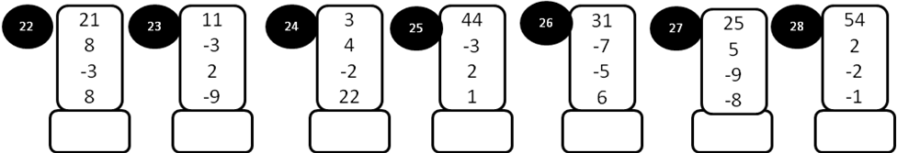

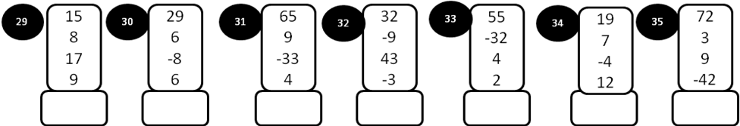

MOEDL PAPER = IV

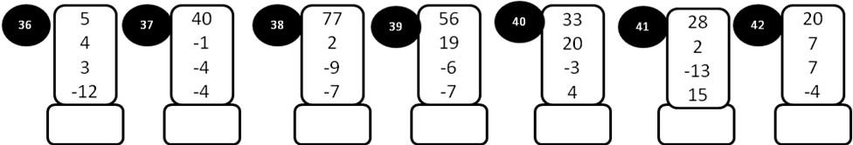
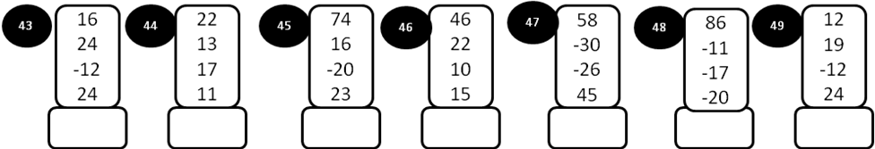
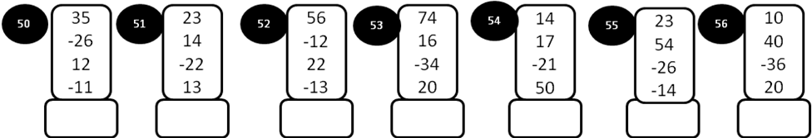
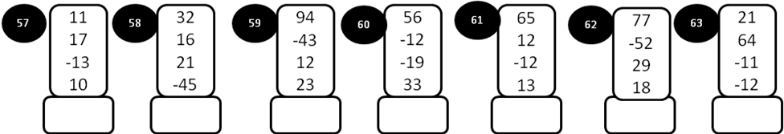

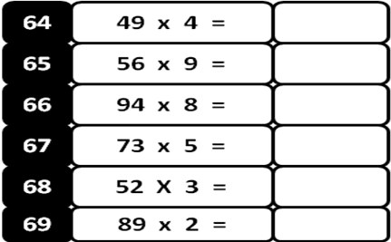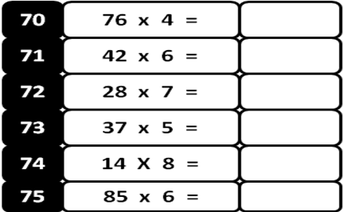

MODEL PAPER = V

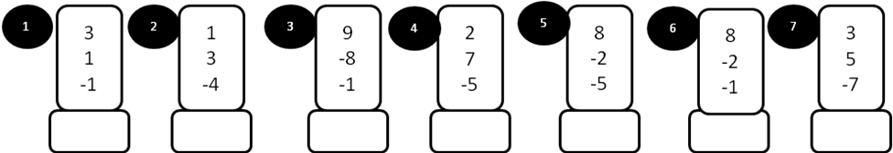

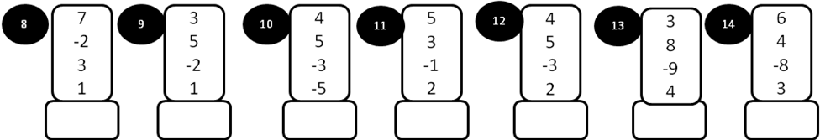

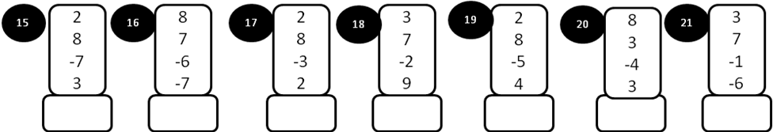

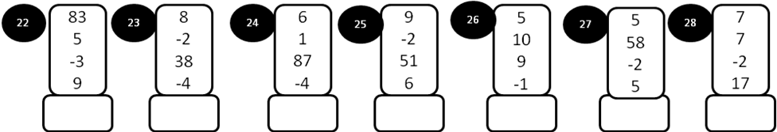

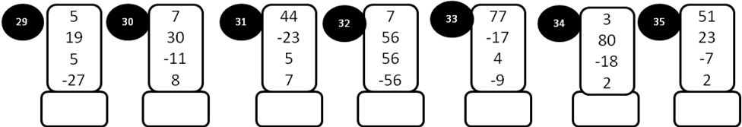

MODEL PAPER = V

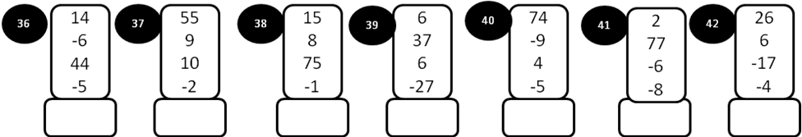
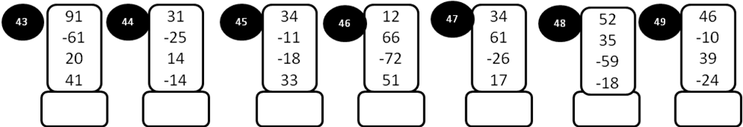
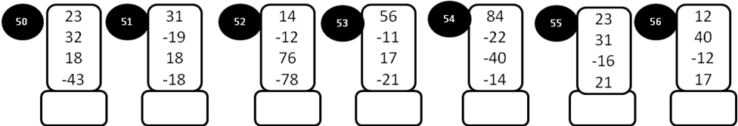
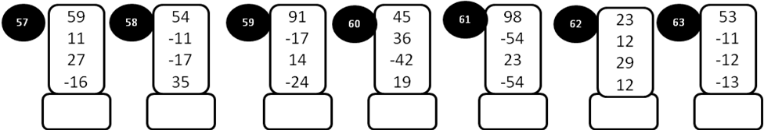

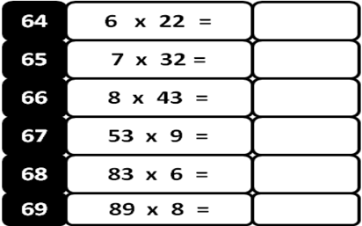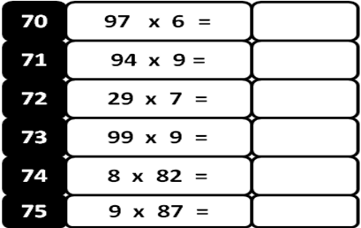

MODEL PAPER = VI

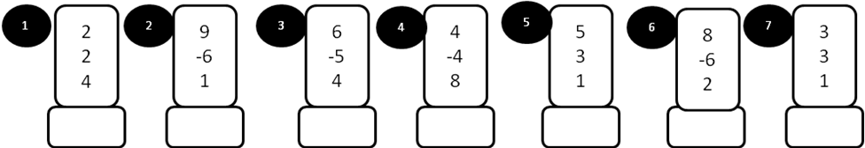

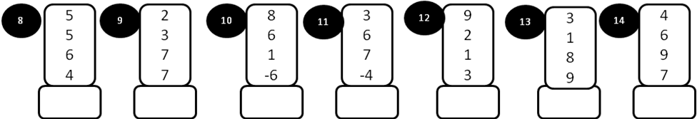

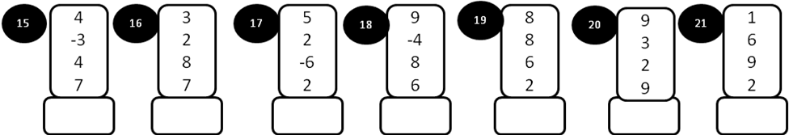

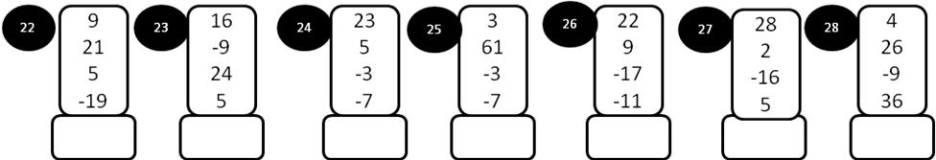

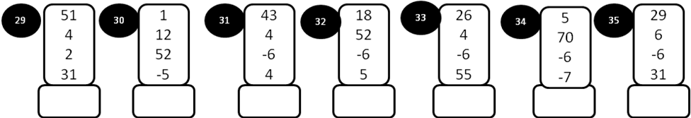
MODEL PAPER = VI

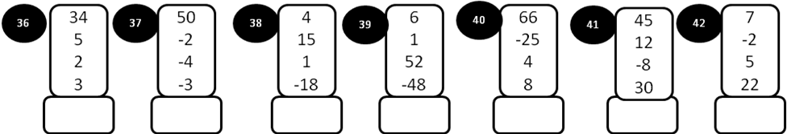
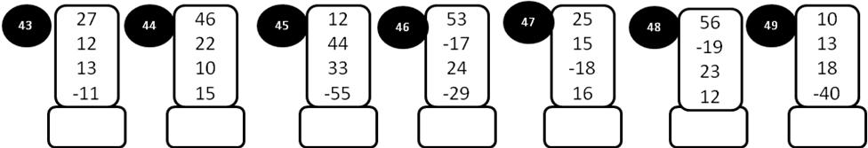
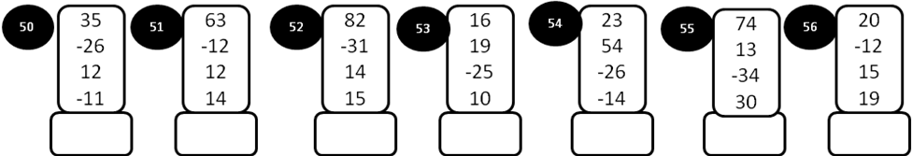
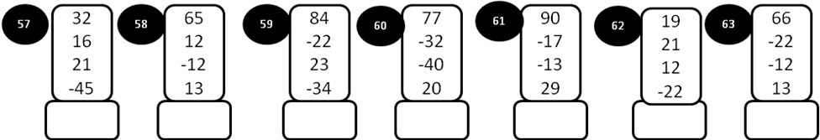

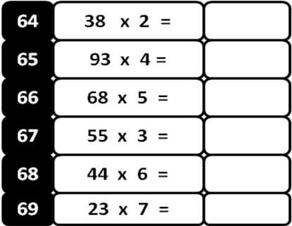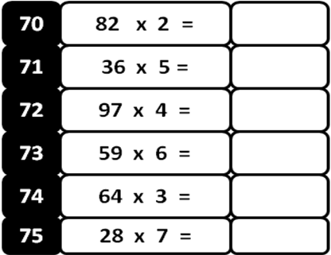
MODEL PAPER = VII

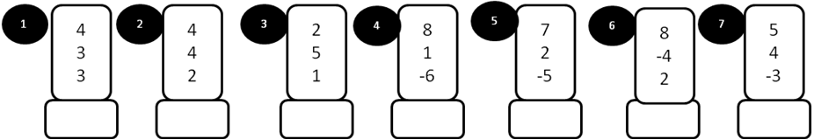

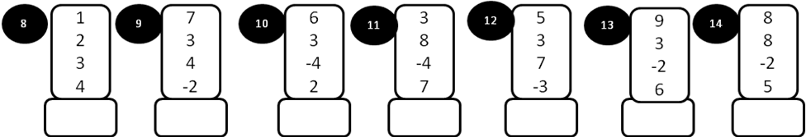

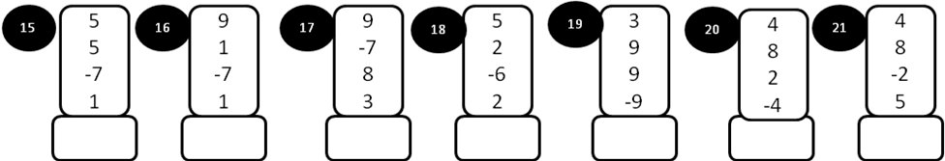

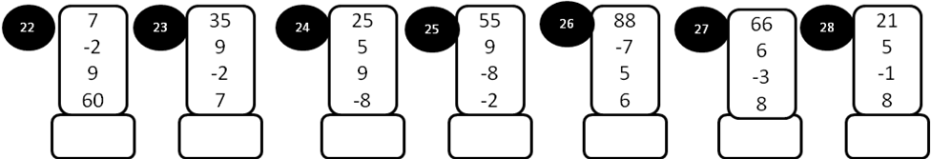

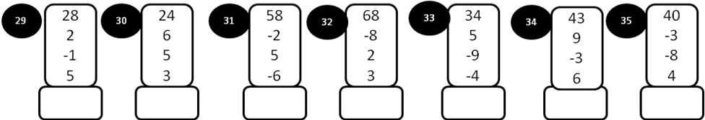

MODEL PAPER = VII

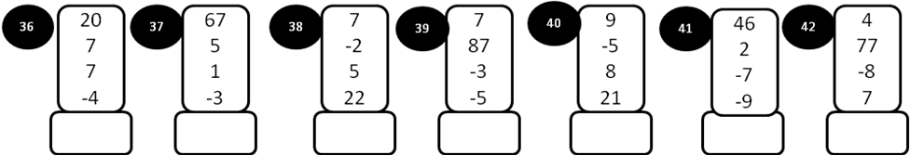
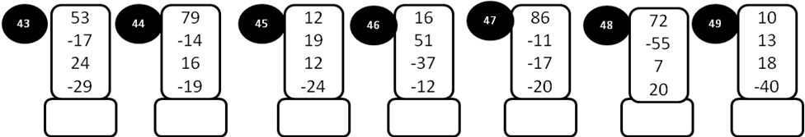
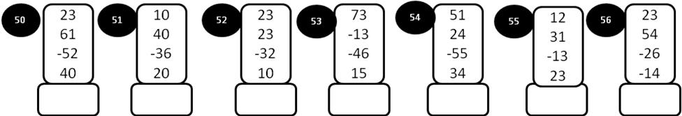
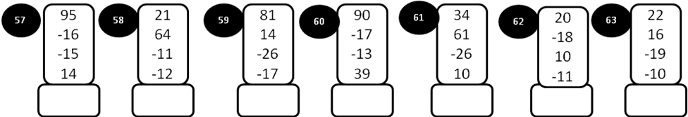

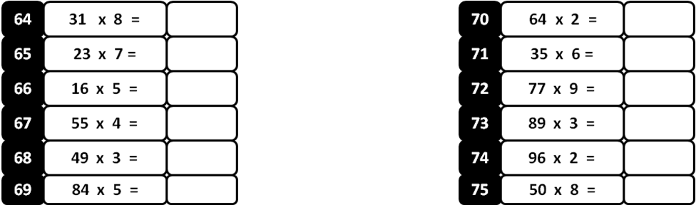

MODEL PAPER =VIII

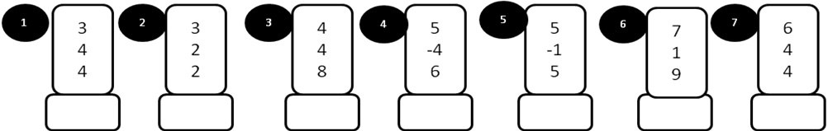

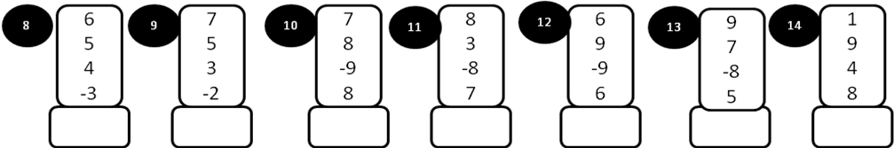

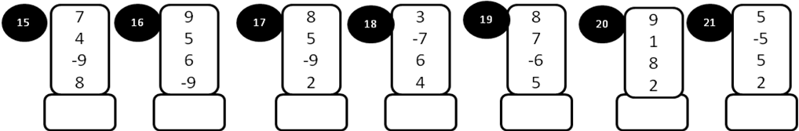

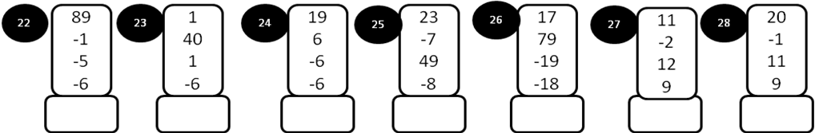

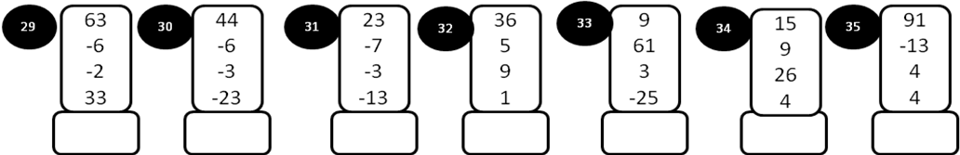

MODEL PAPER VIII

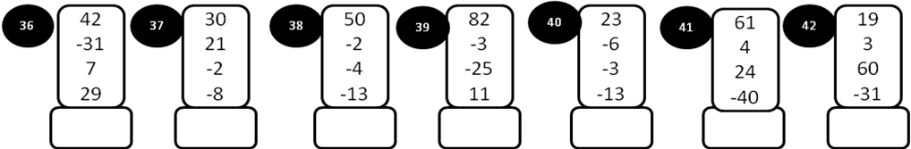
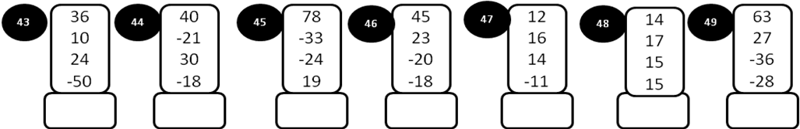
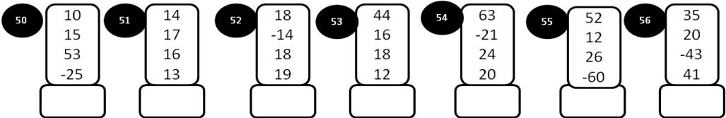
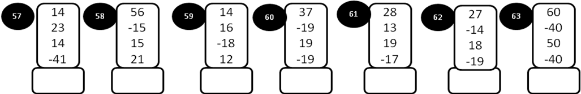

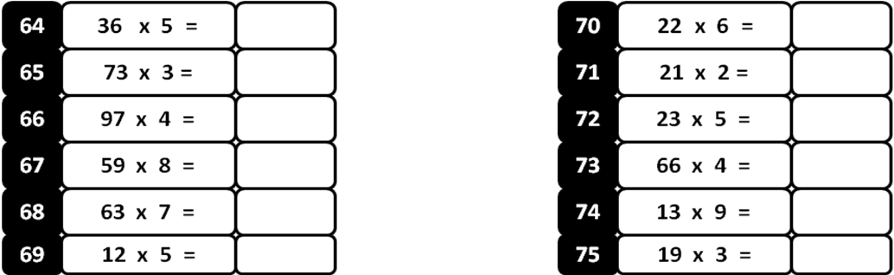

MODEL PAPER –IX

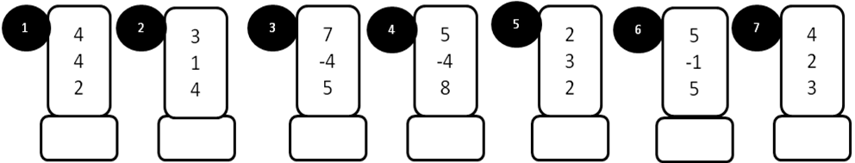
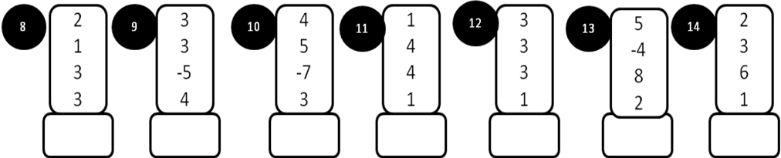
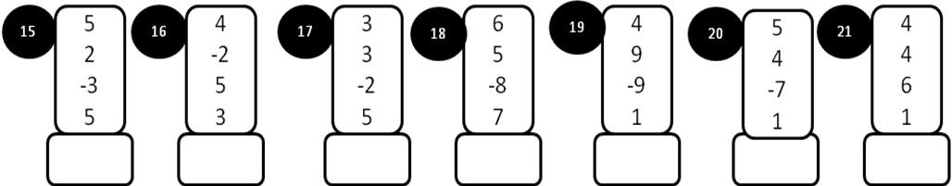
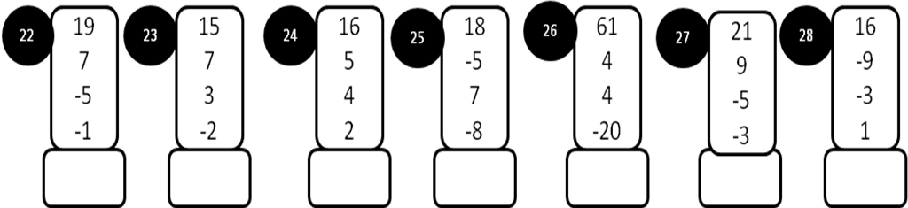

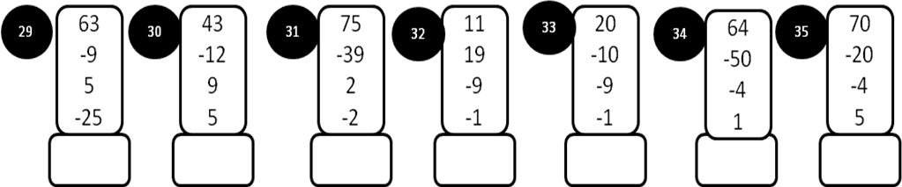
MODEL PAPER = IX

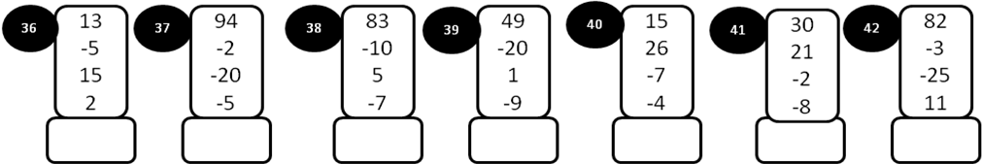
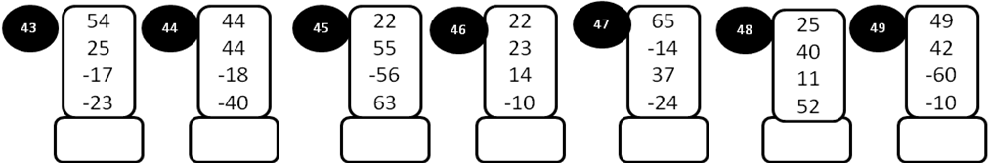
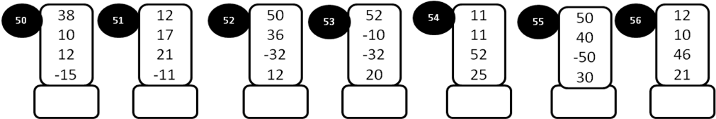
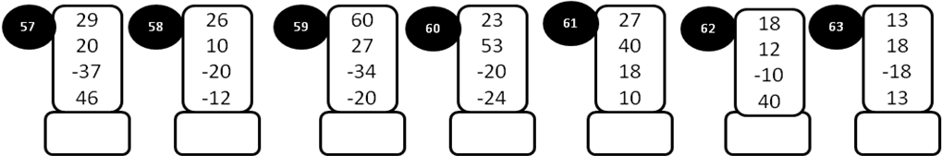

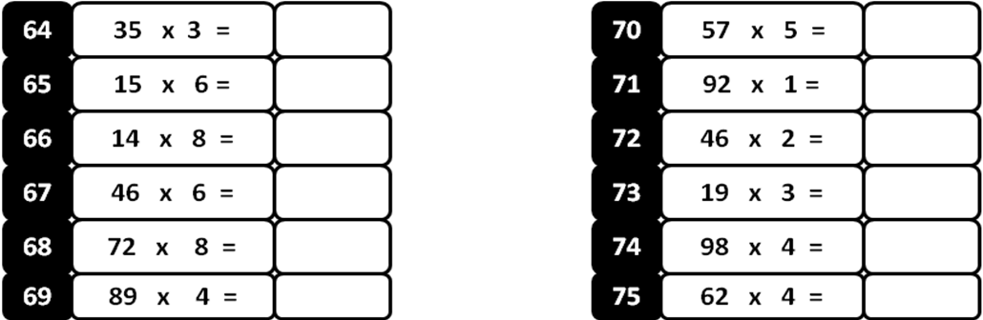
MODEL PAPER =X
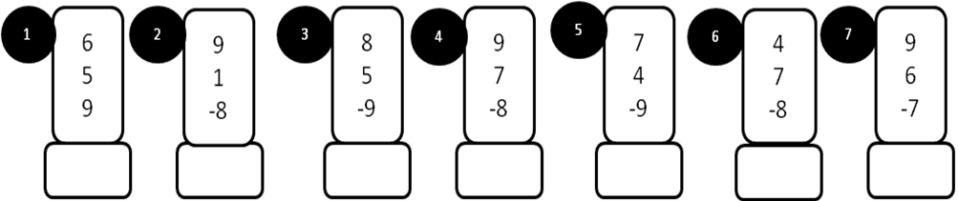
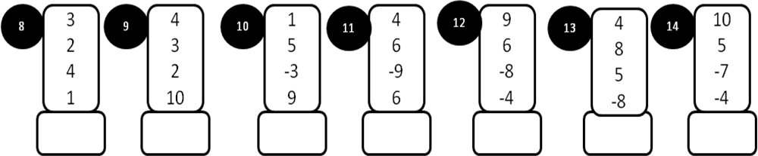
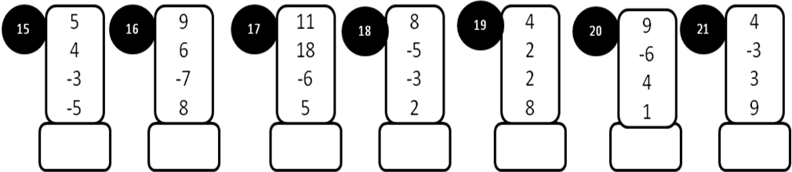
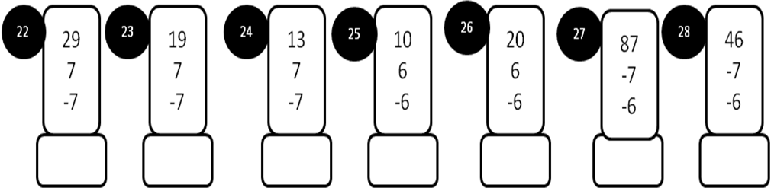
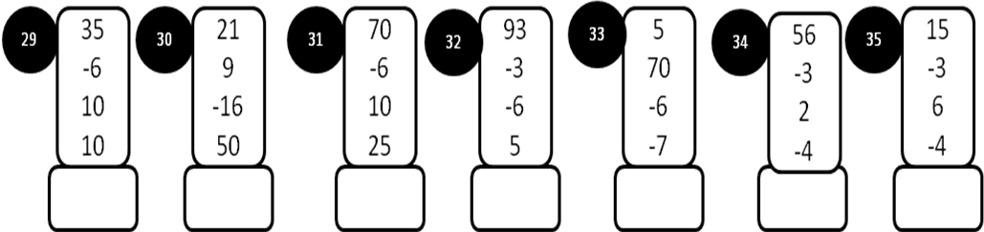
MODEL PAPER = X
