MODEL PAPER = I
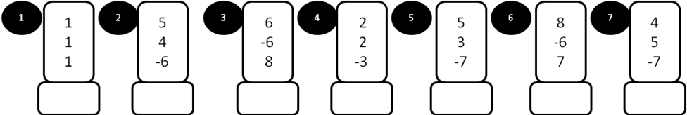

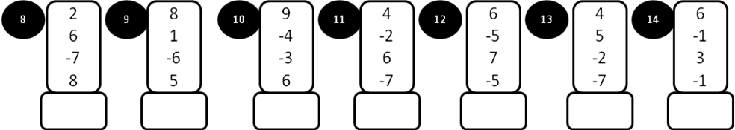

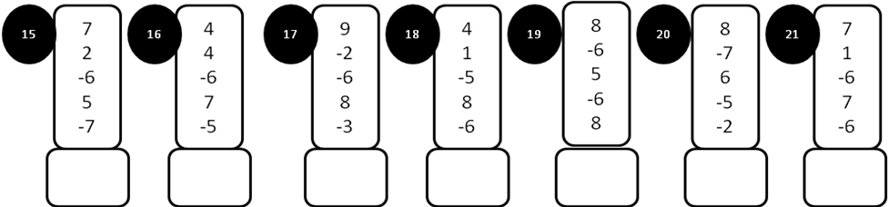

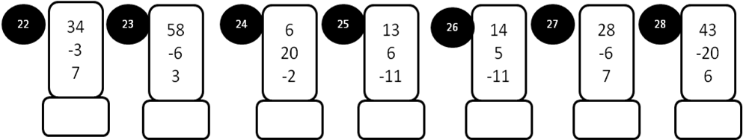

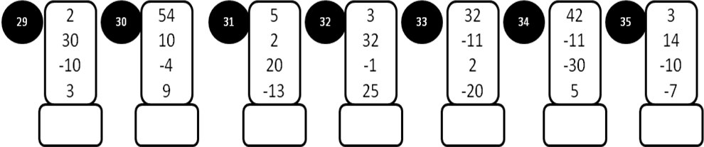
MODEL PAPER – I
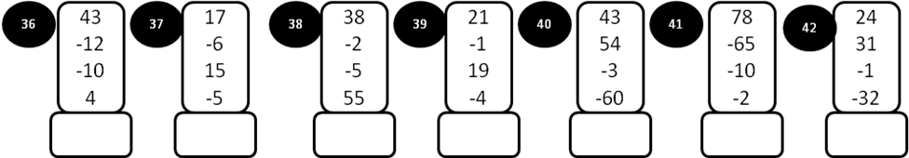
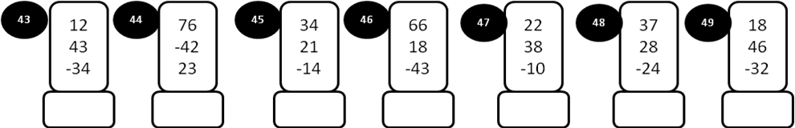
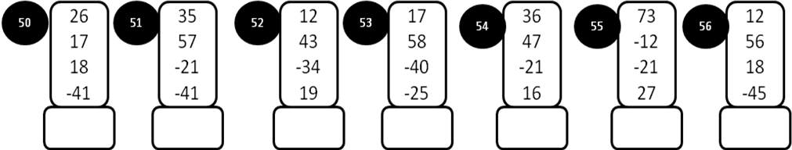
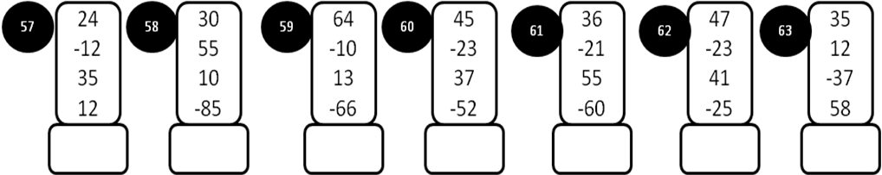
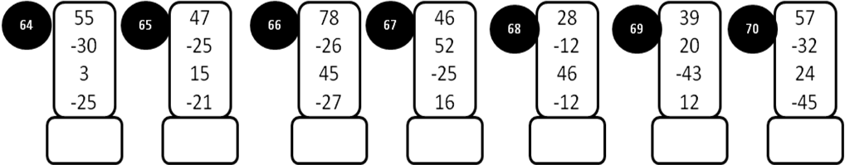
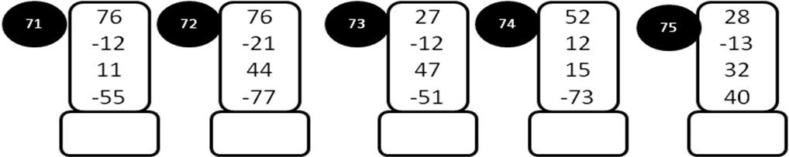
MODEL PAPER =II

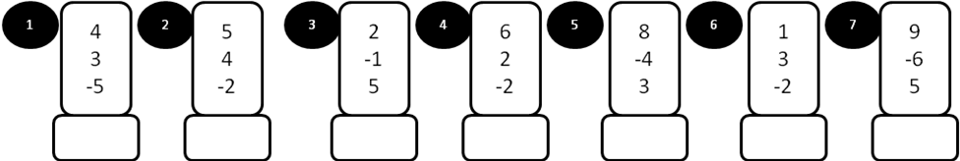

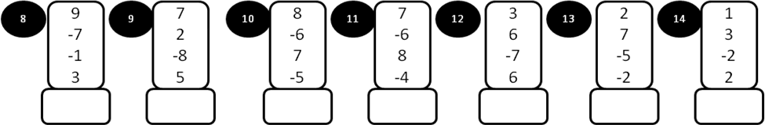

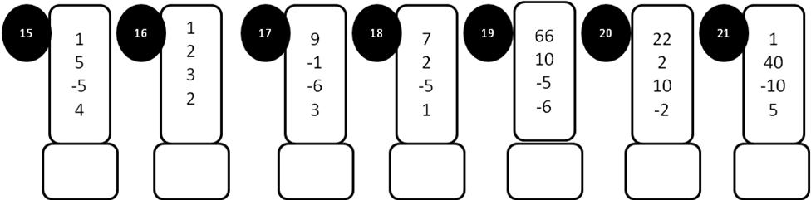

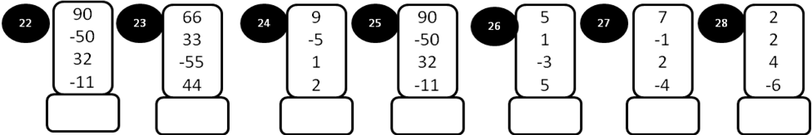

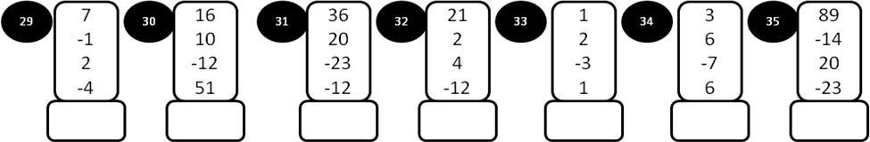
MODEL PAPER =II
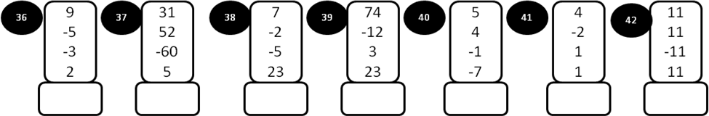
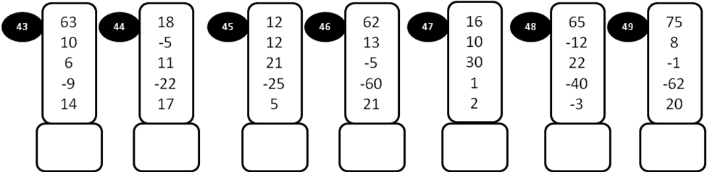
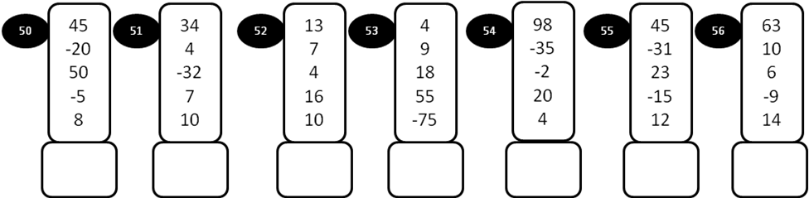
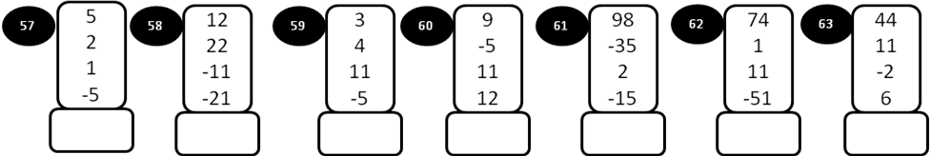
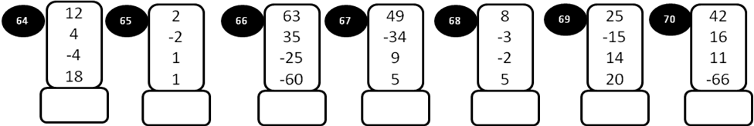
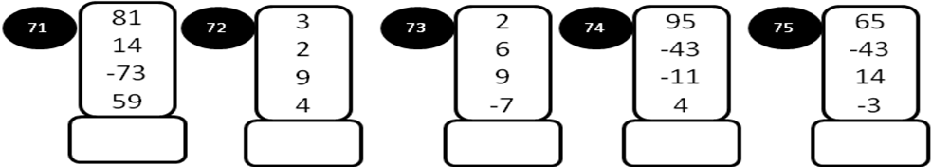
MODEL PAPER = III
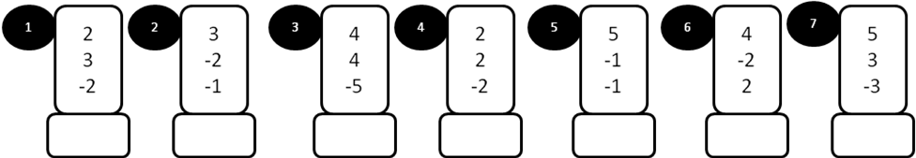

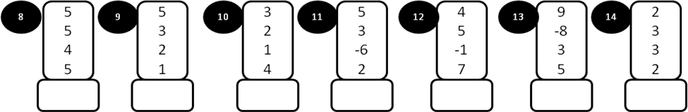

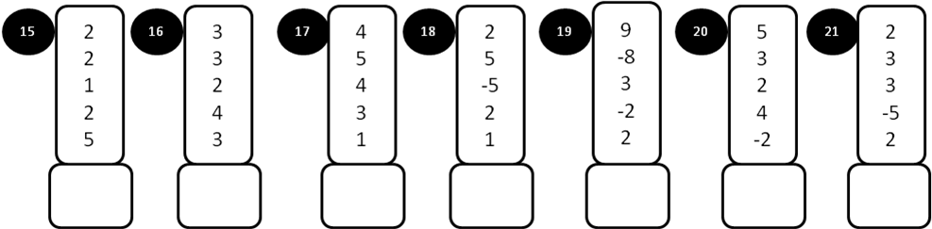

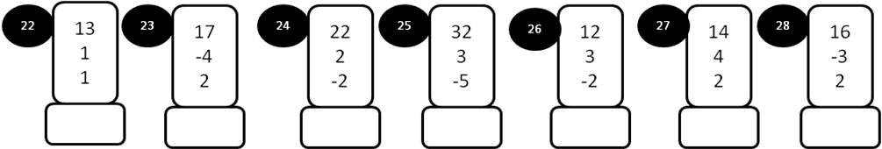

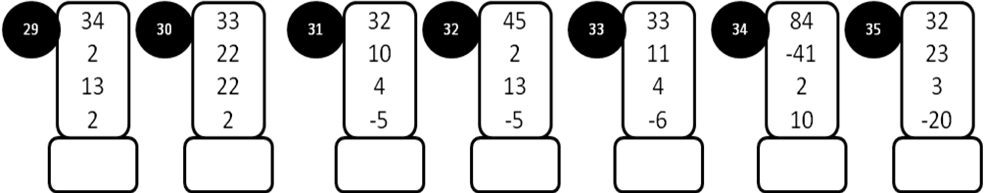
MODEL PAPER = III

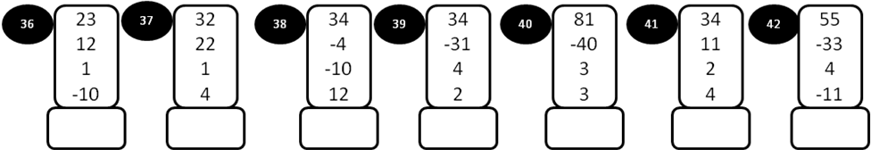
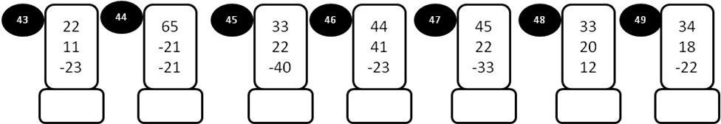
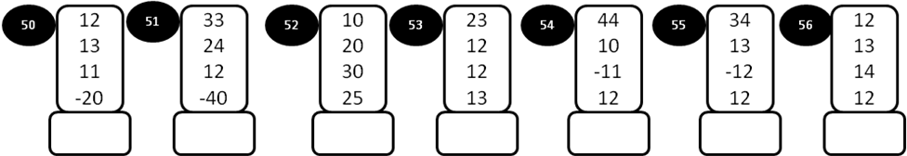
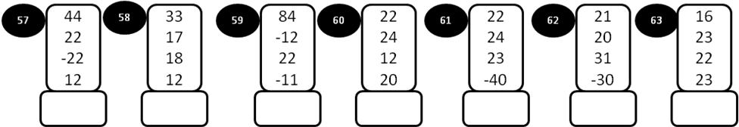
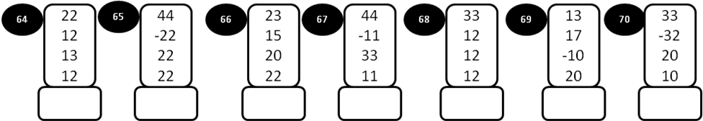
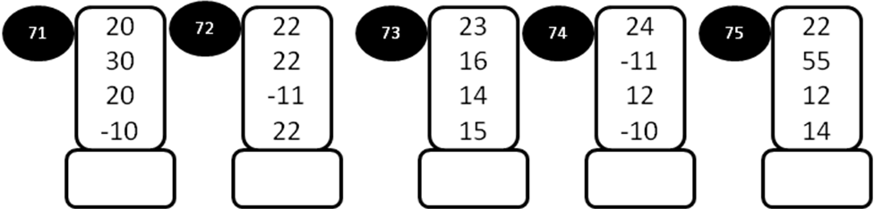
MODEL PAPER =IV

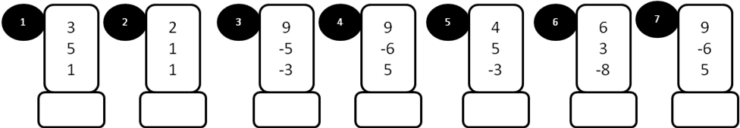
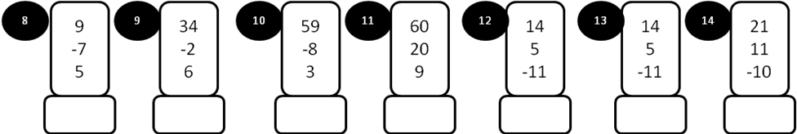
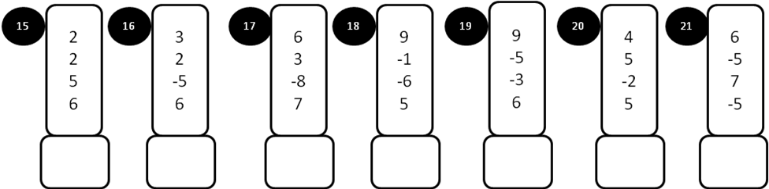
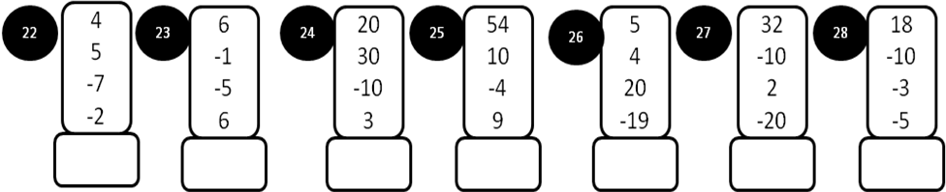

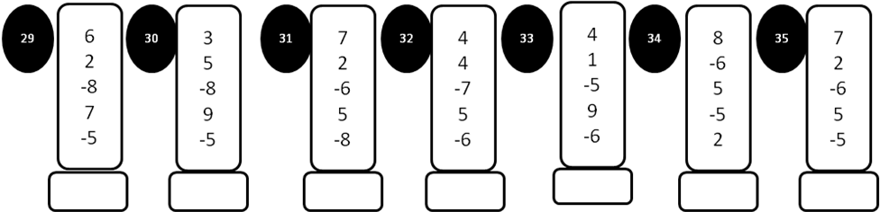

MODEL PAPER =IV
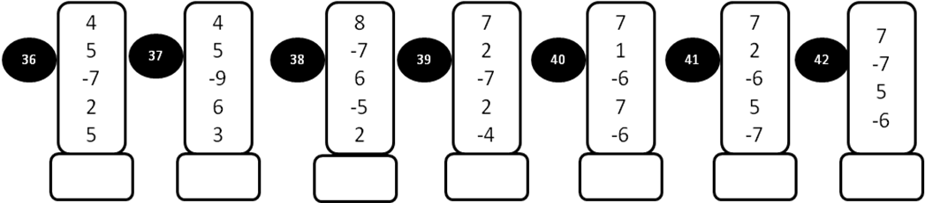
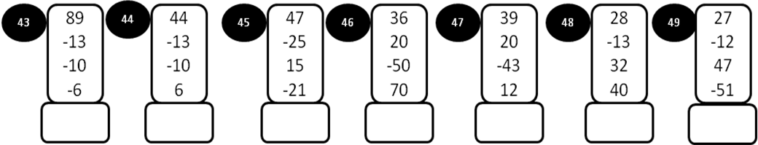
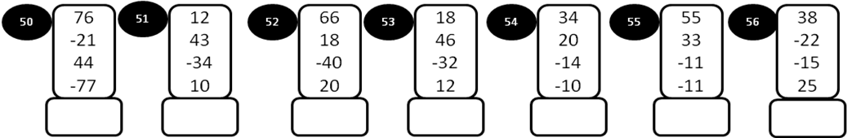
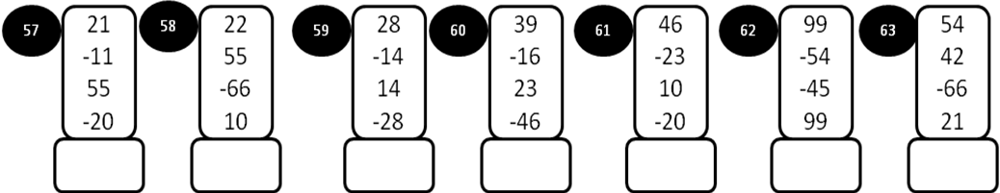
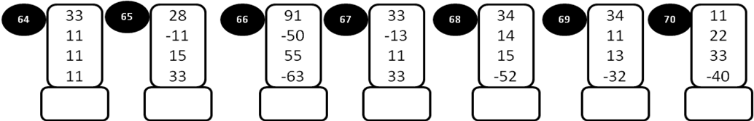
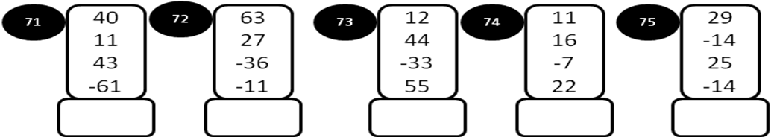
MODEL PAPER=V

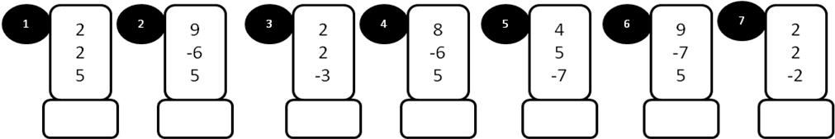
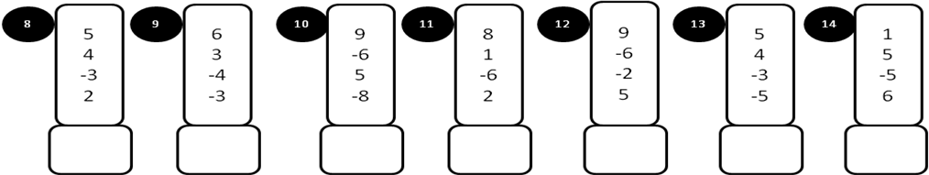
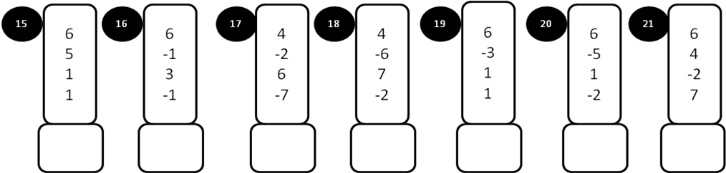
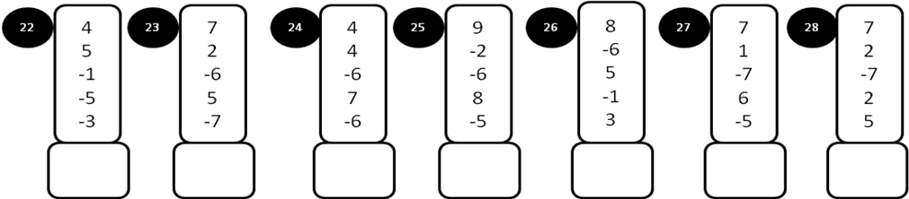
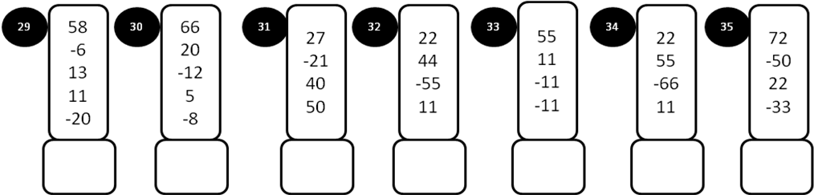

MODEL PAPER=V
