MODEL PAPER = I

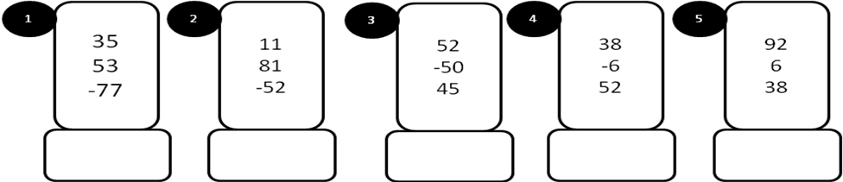
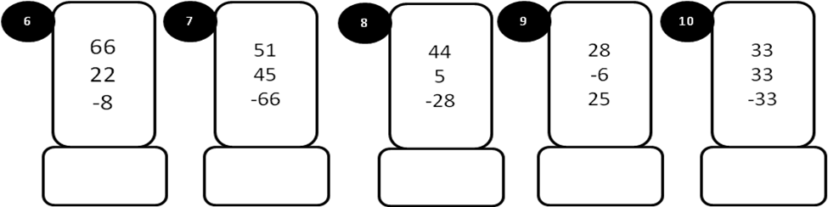
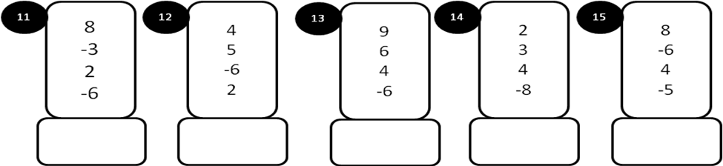
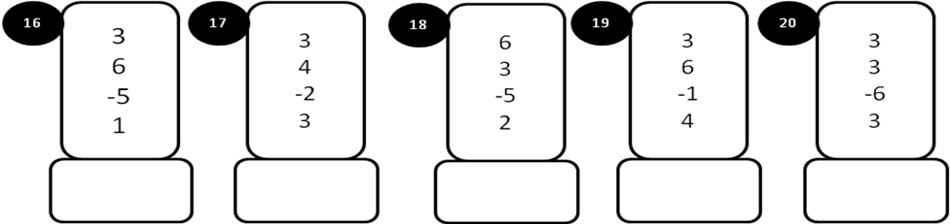
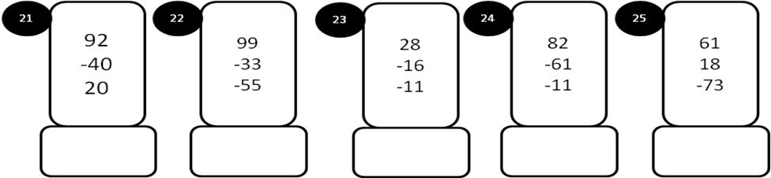
MODEL PAPER –I
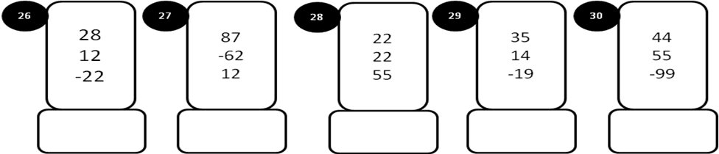
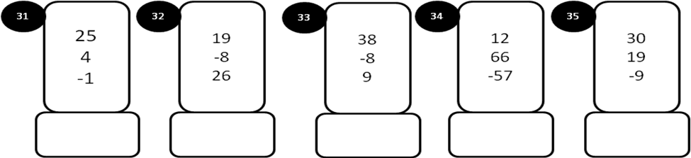
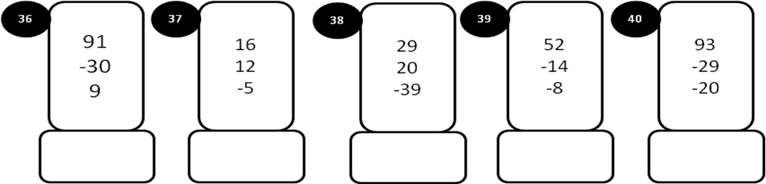
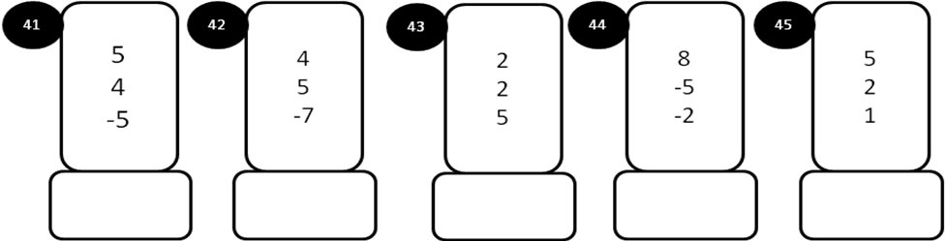
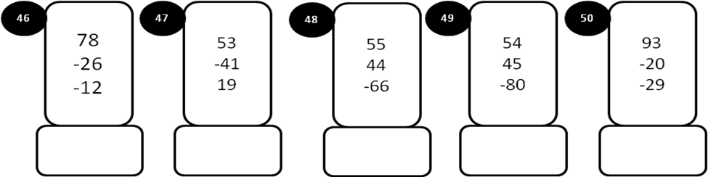
MODEL PAPER = II
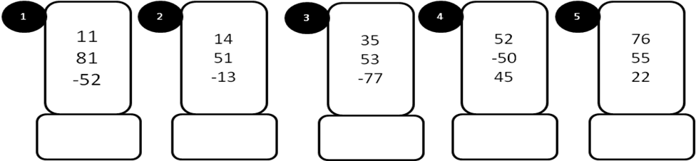
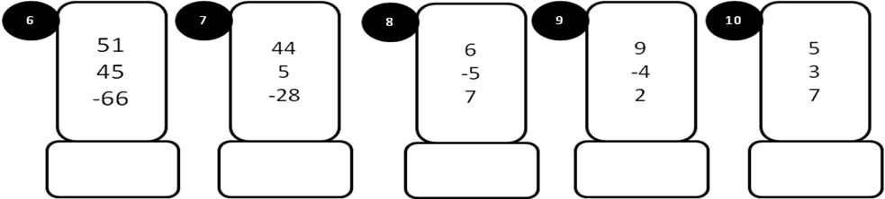
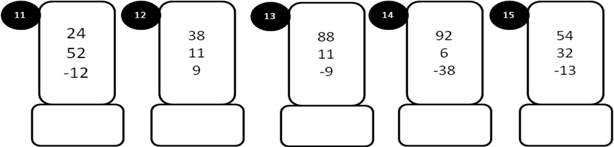
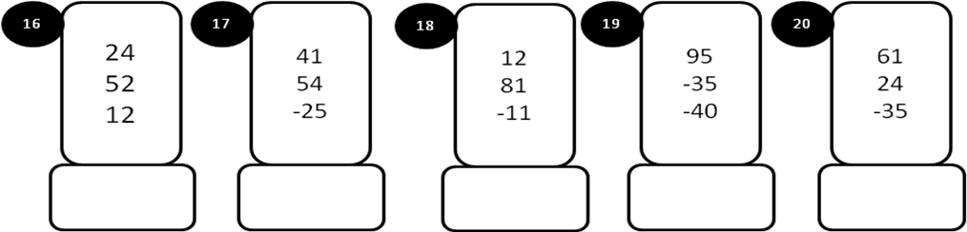
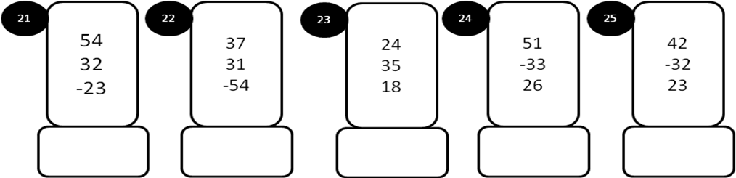
MODEL PAPER =II

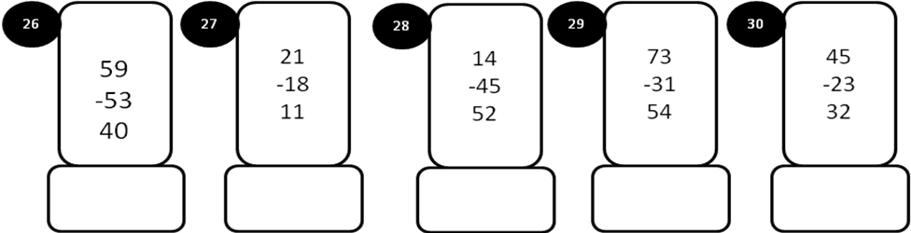
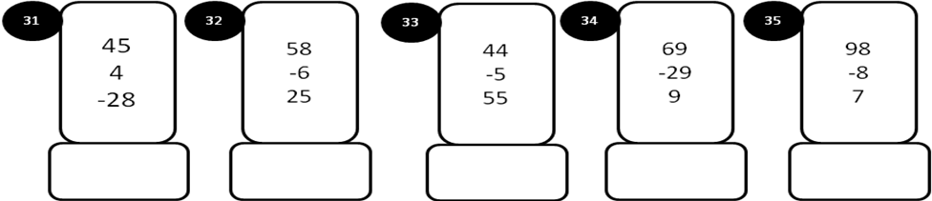
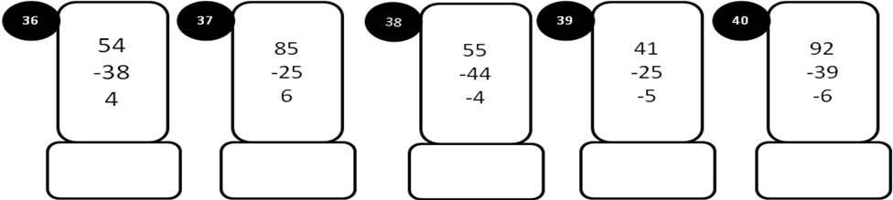
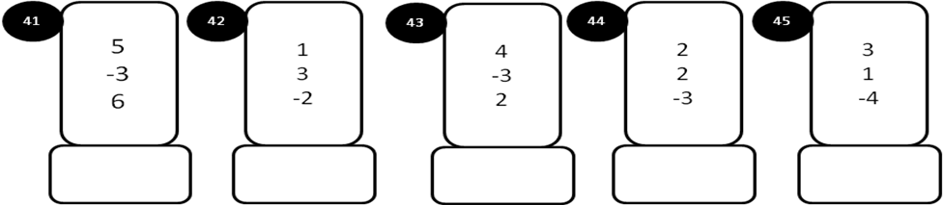
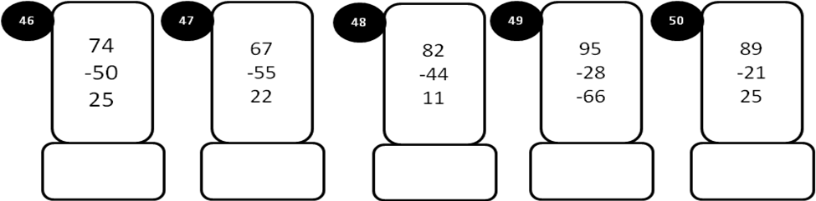
MODEL PAPER =III

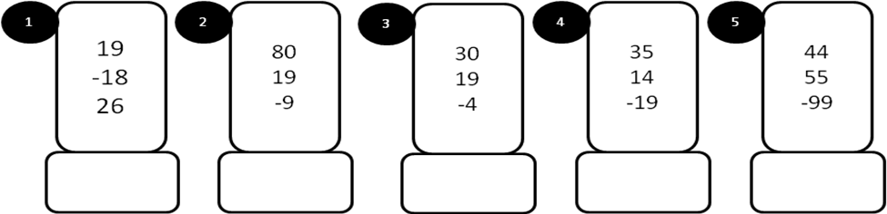
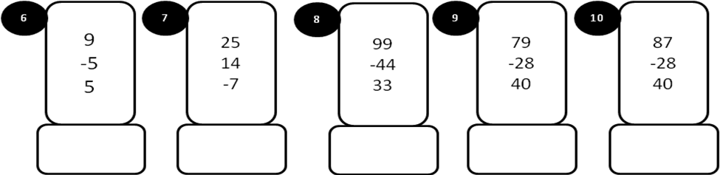
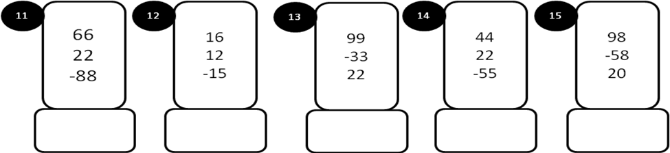
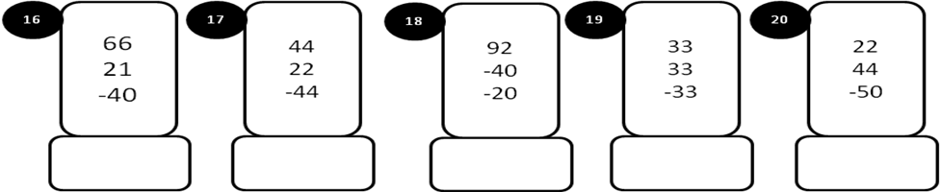
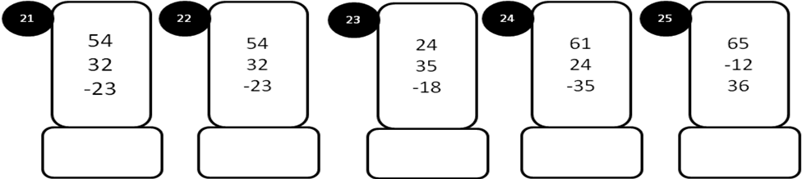
MODEL PAPER =III
