MODEL PAPER – I
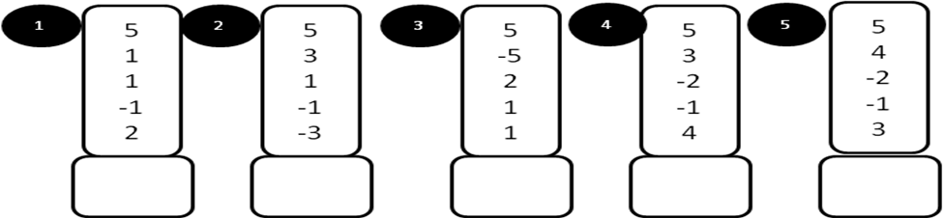
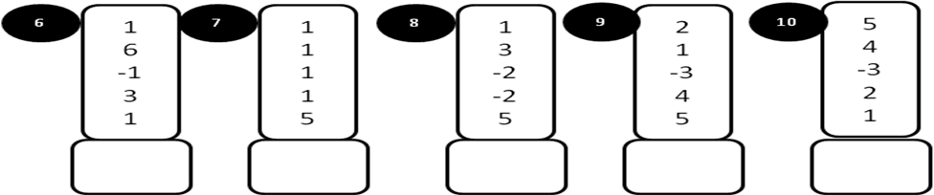
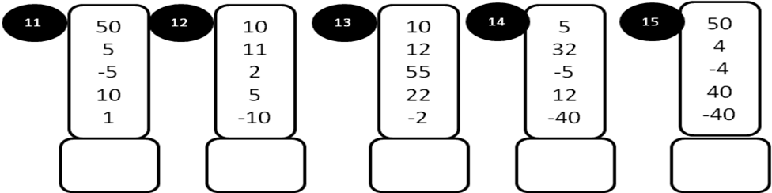
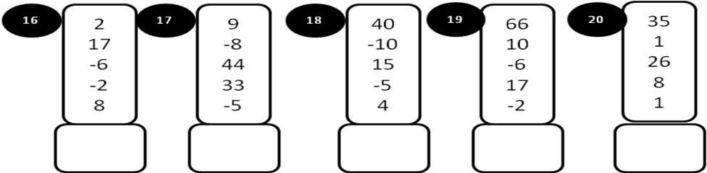
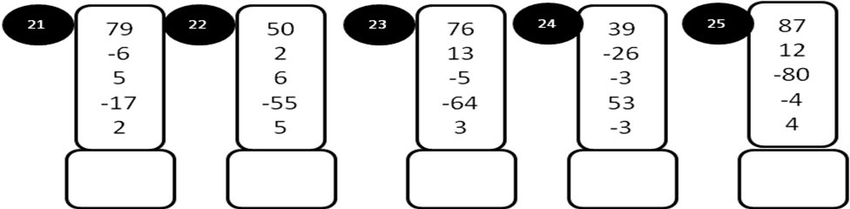
MODEL PAPER – I
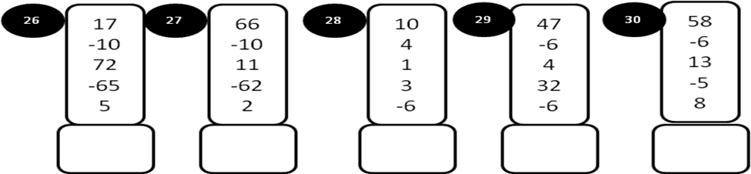
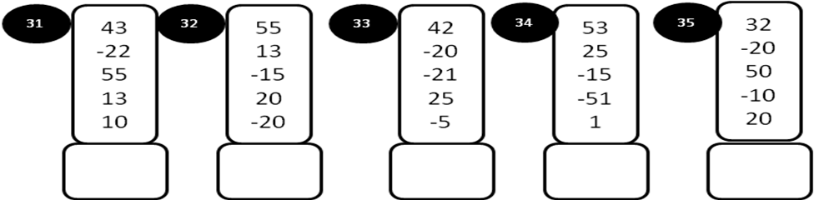
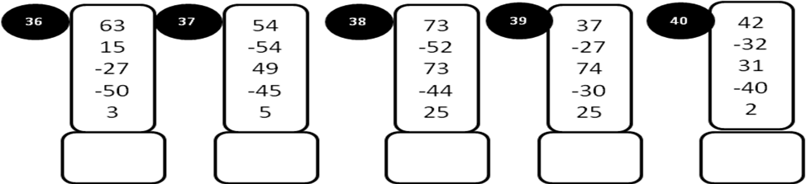
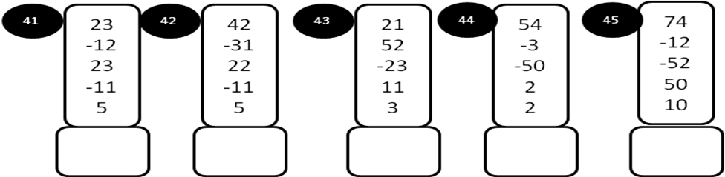
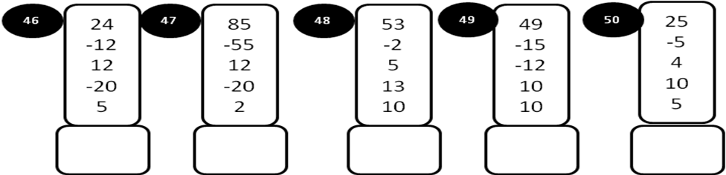
MODEL PAPER –II
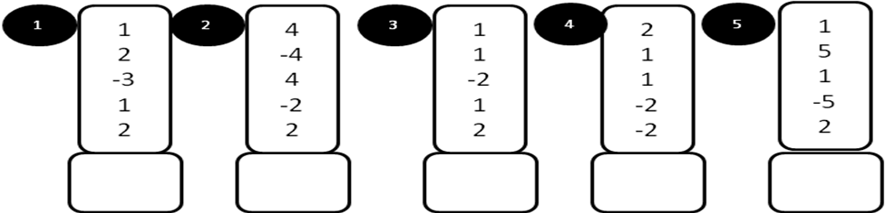
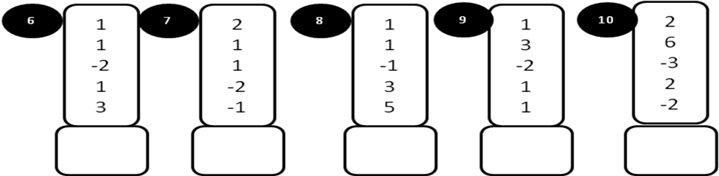
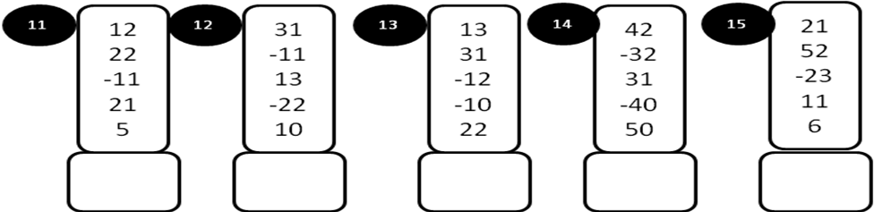
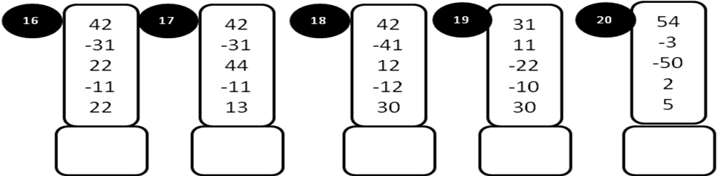
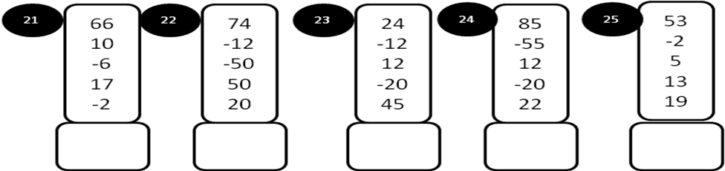
MODEL PAPER = II
