MODEL PAPER = I

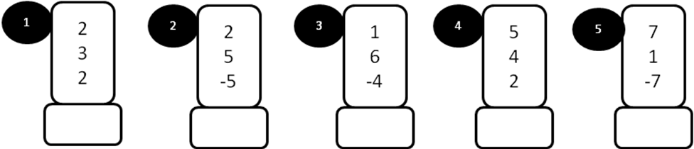
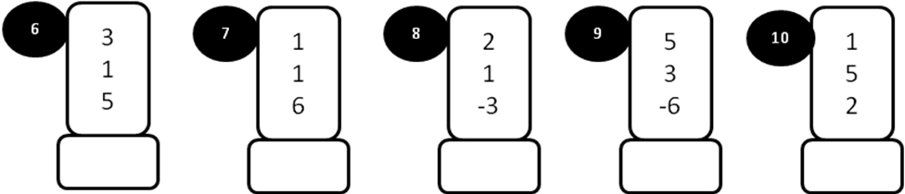
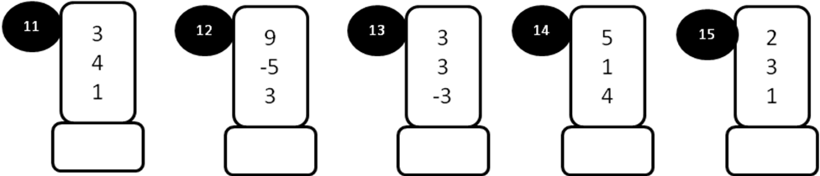
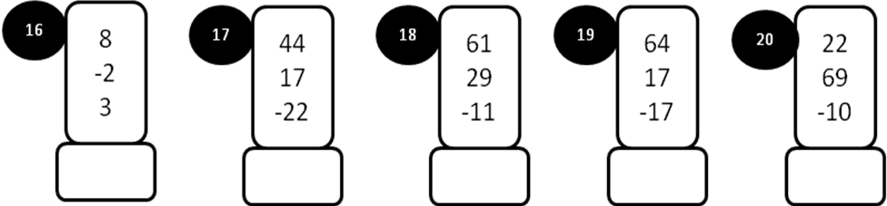
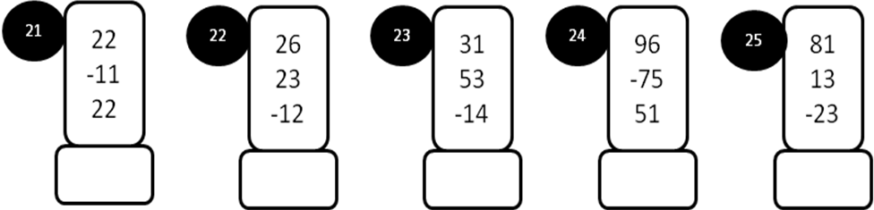
MODEL PAPER = I
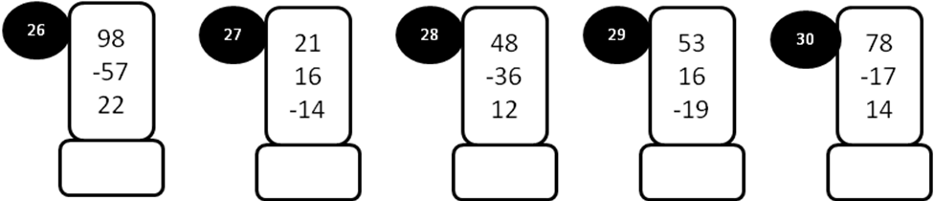
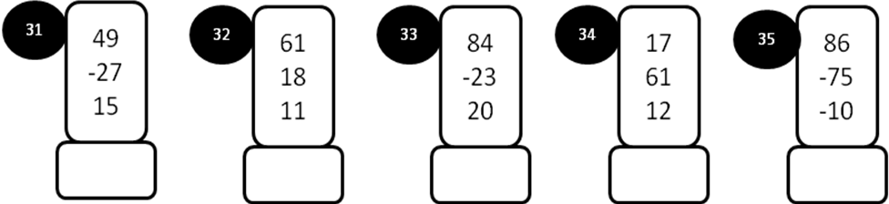
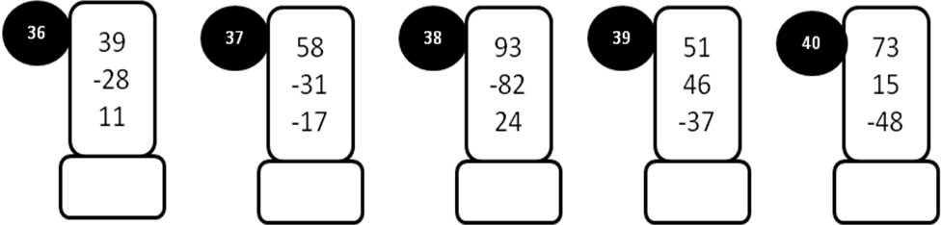
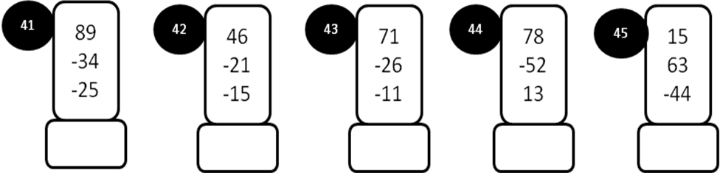
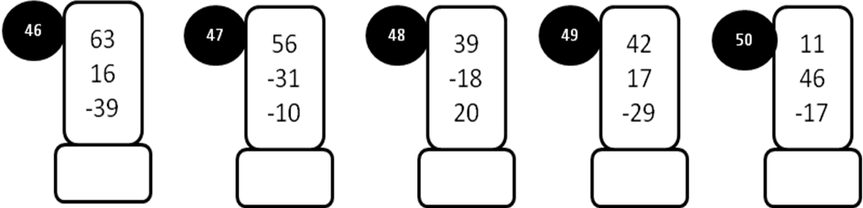
MODEL PAPER=II
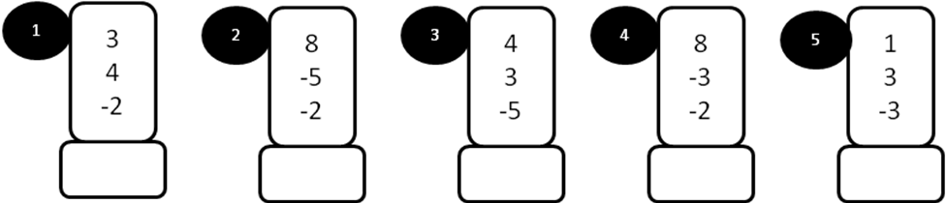
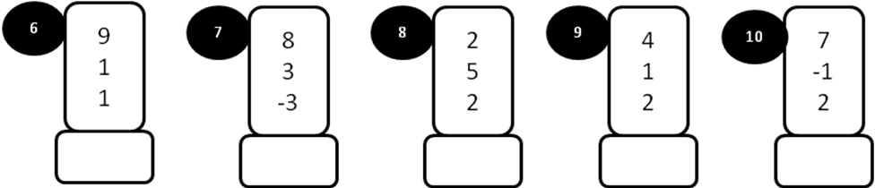
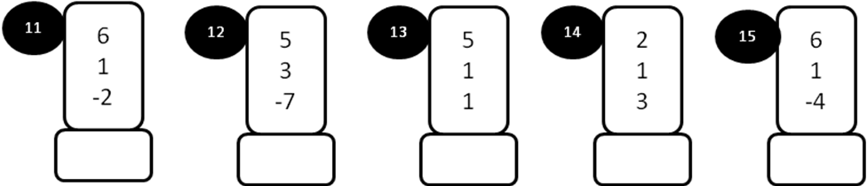
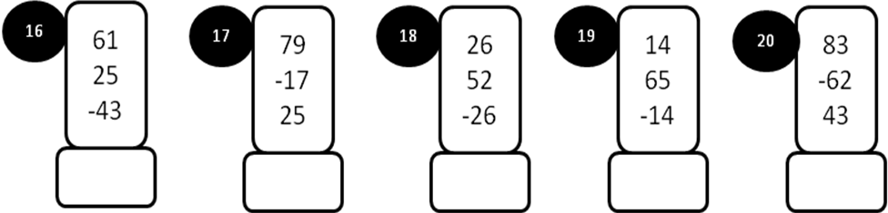
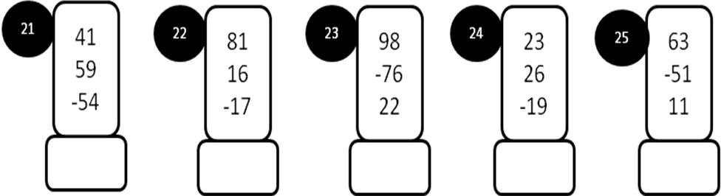
MODEL PAPER =II
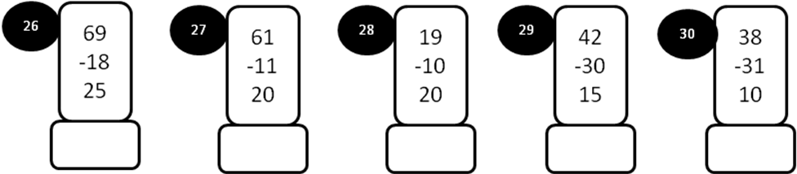
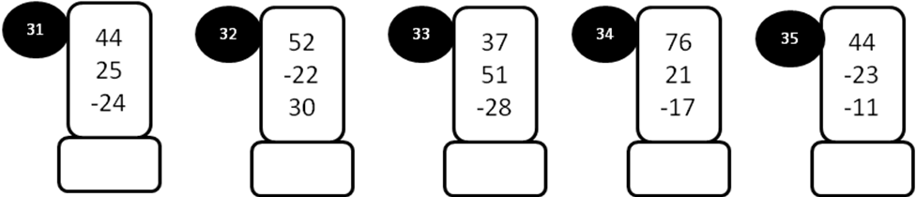
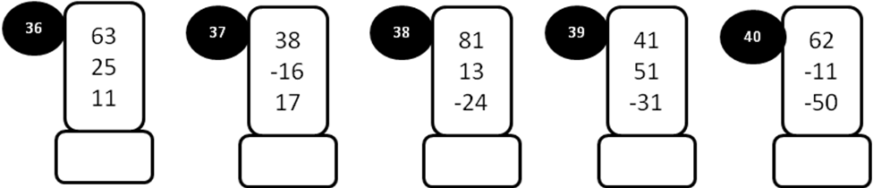
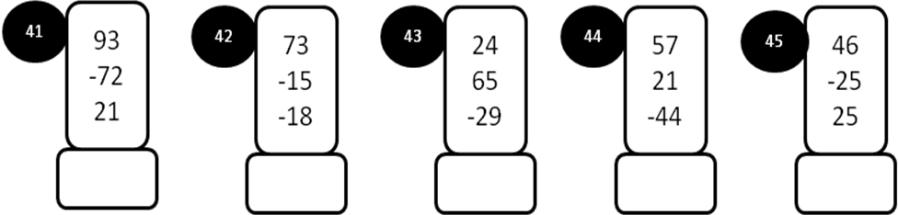
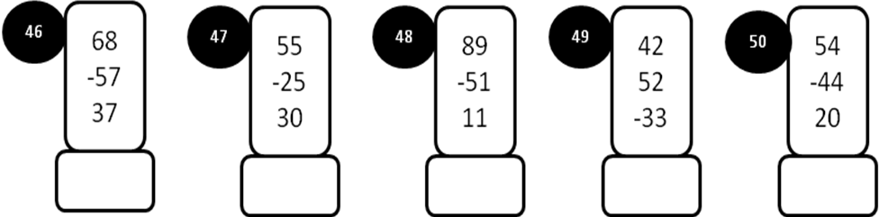

MODEL PAPER =III

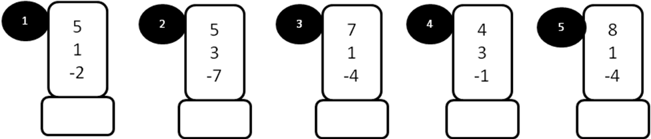
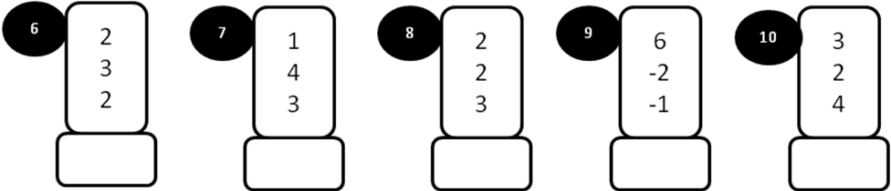
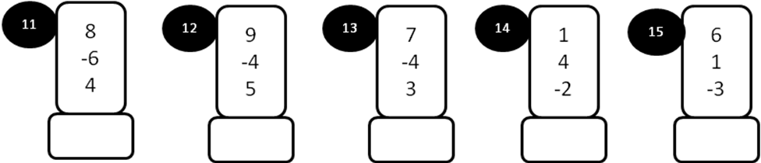
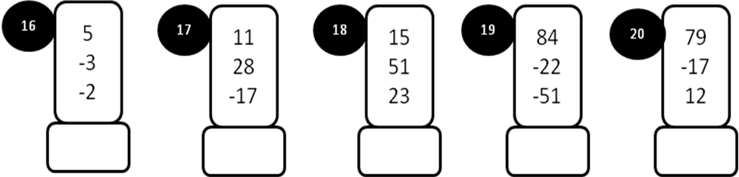
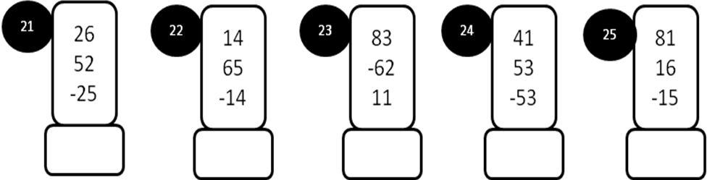
MODEL PAPER =III

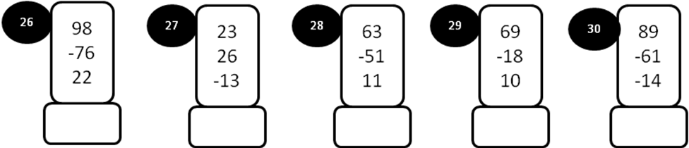
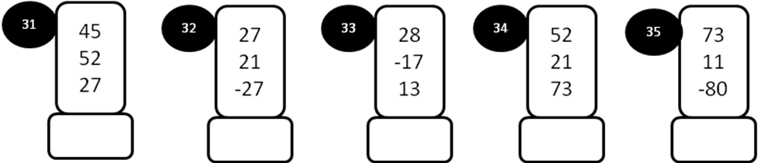
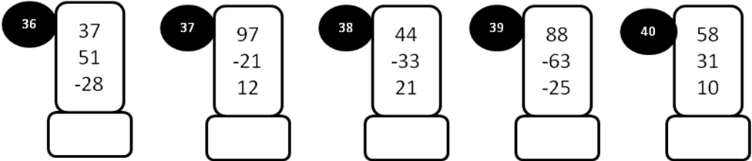
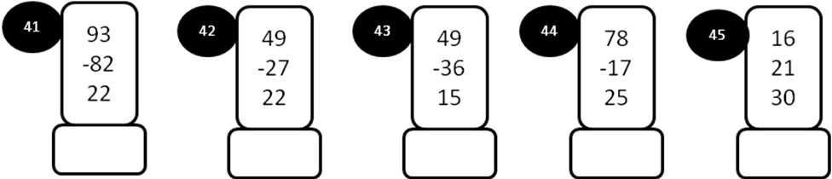
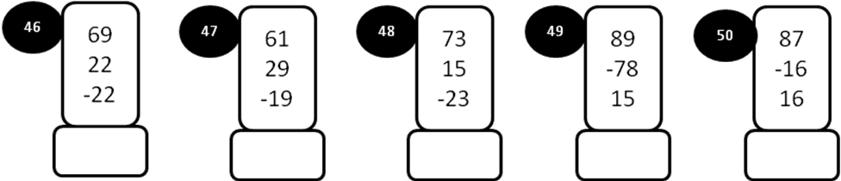

MODEL PAPER=IV

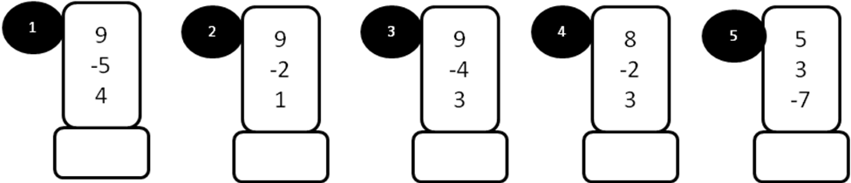
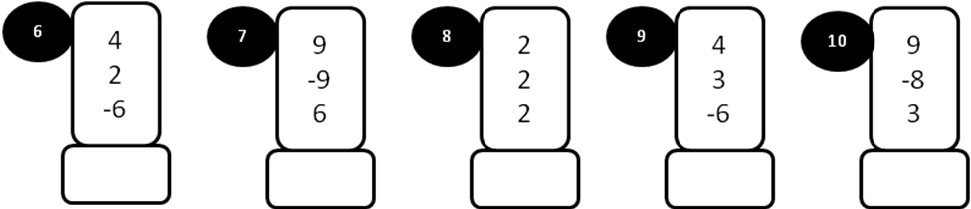
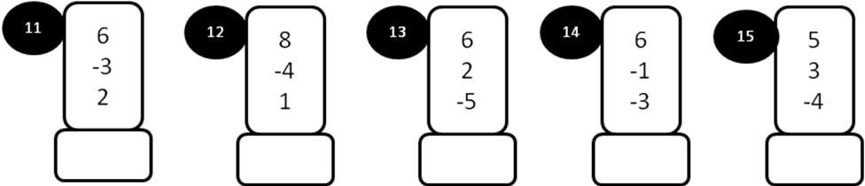
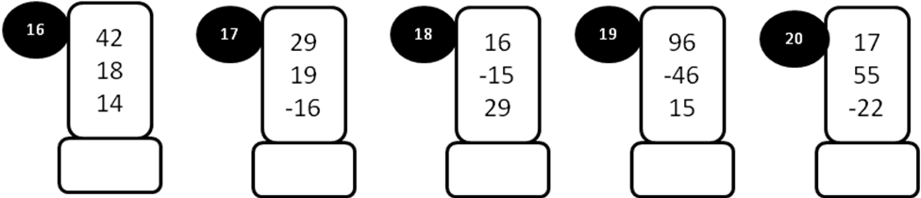

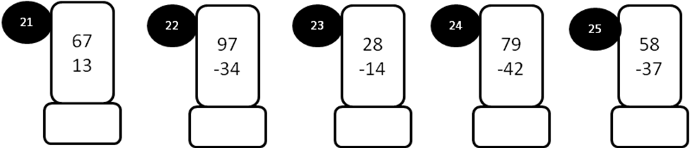
MODEL PAPER =IV

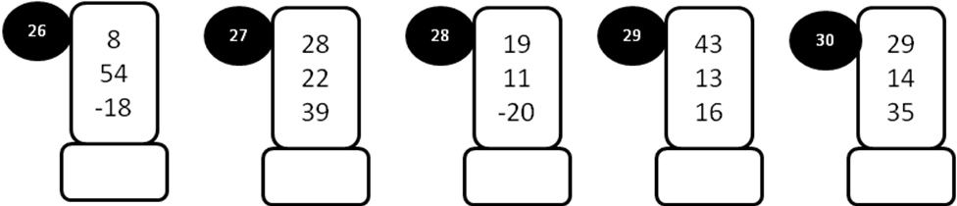
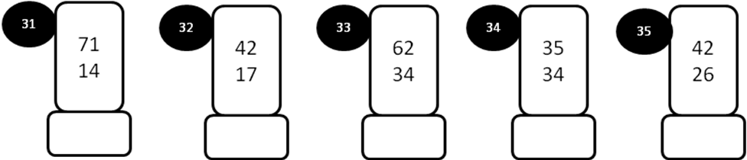
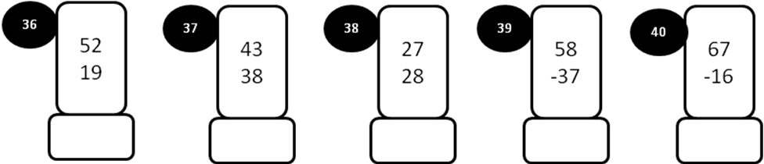
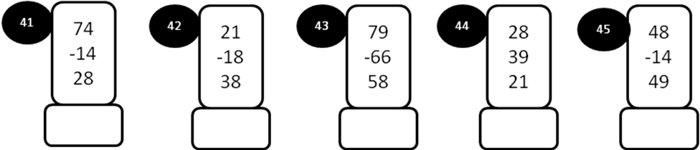
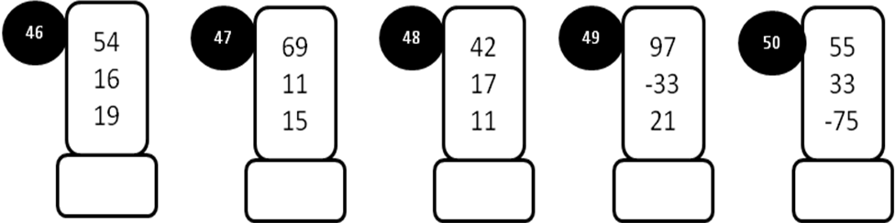
MODEL PAPER =V

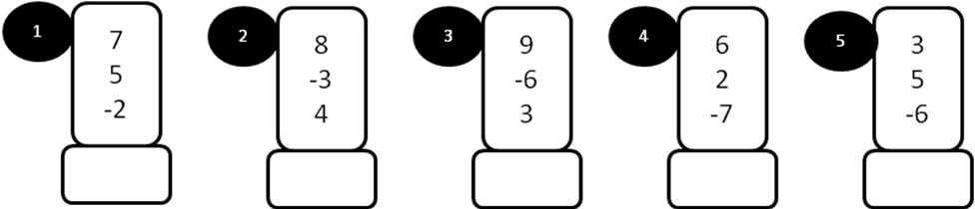
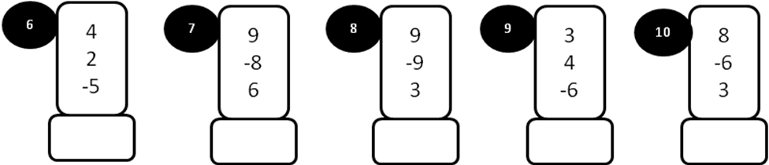
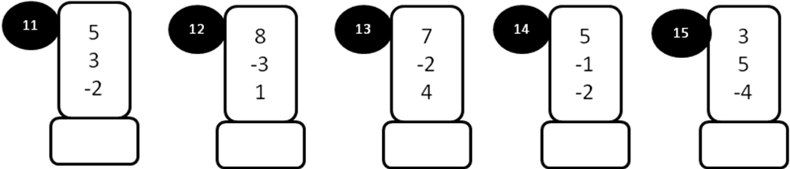
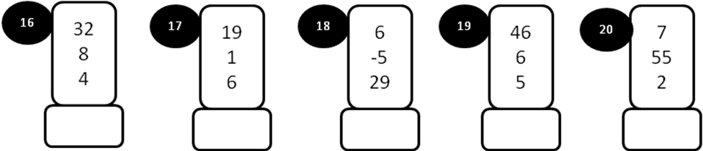
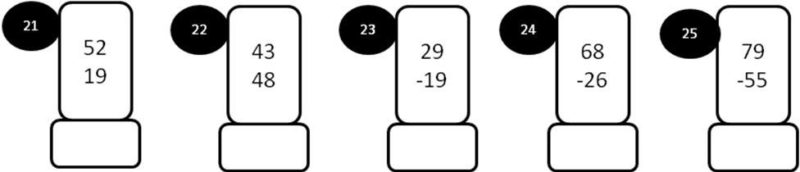

MODEL PAPER =V
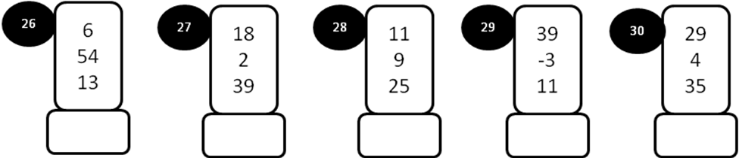
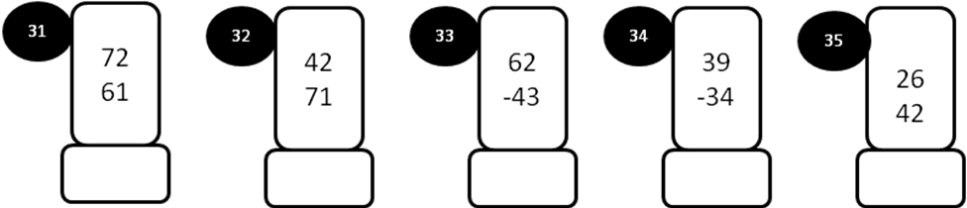
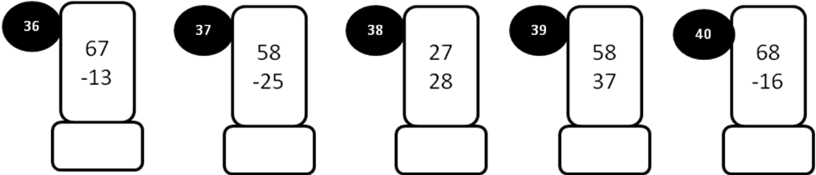
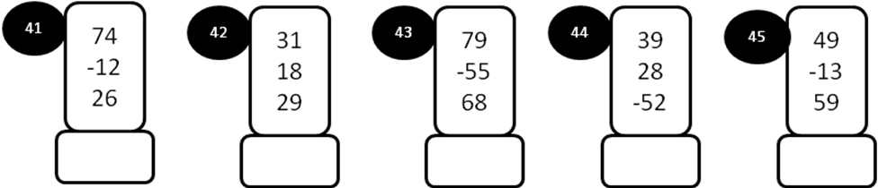
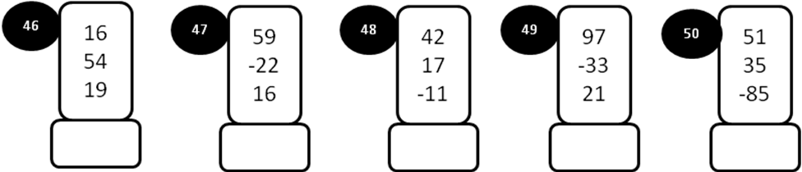

MODEL PAPER=VI

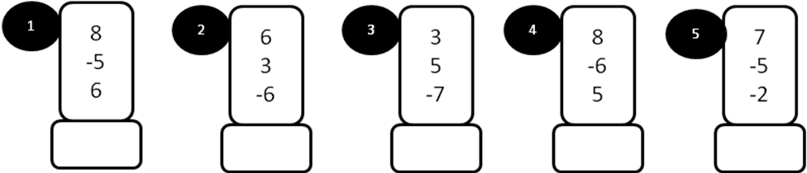
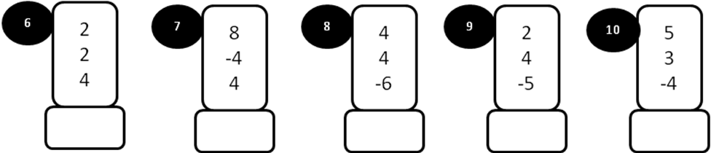
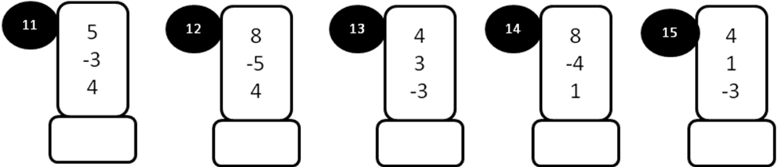
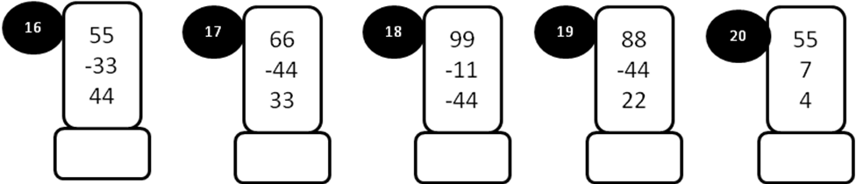
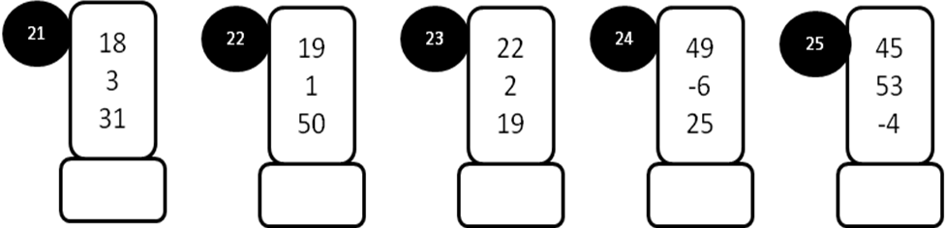
MODEL PAPER=VI
