MODEL PAPER -I

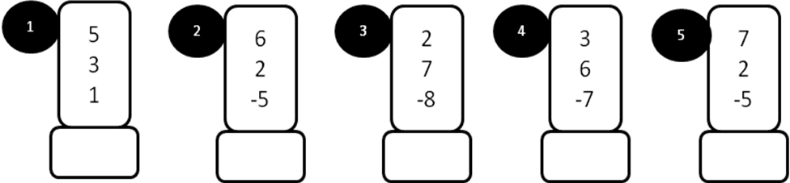
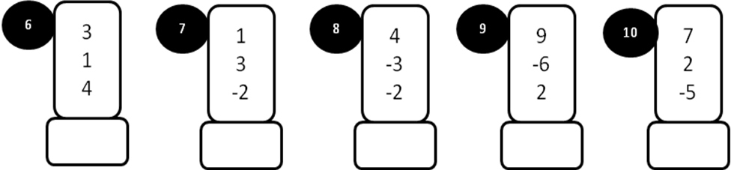
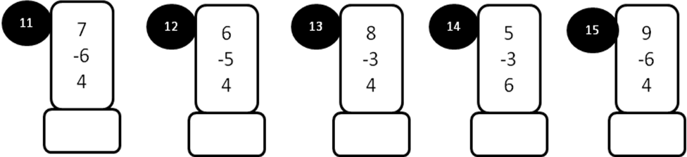
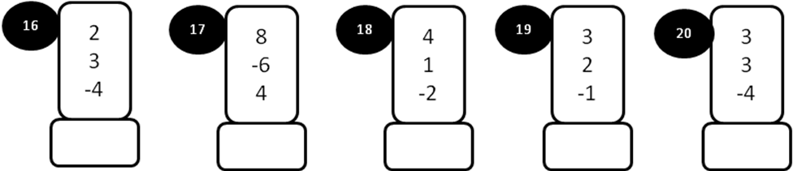
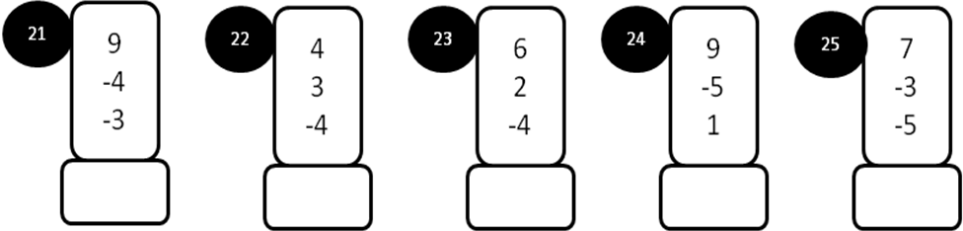
MODEL PAPER=I

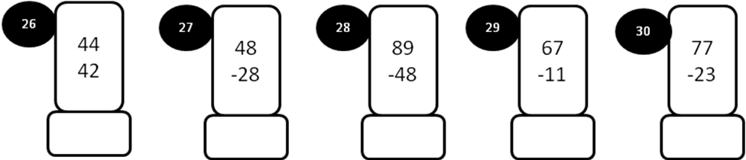
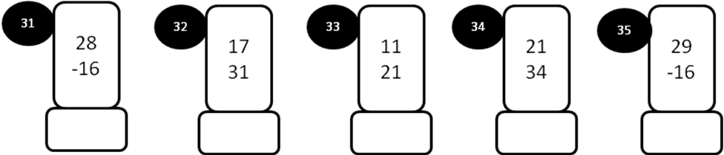
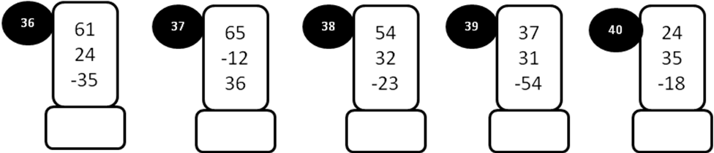
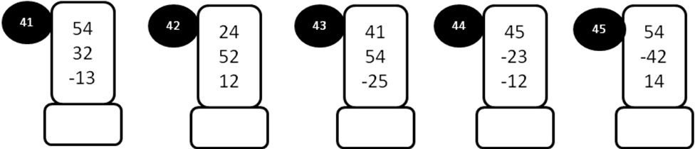
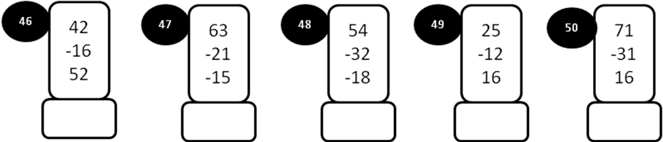

MODEL PAPER = II

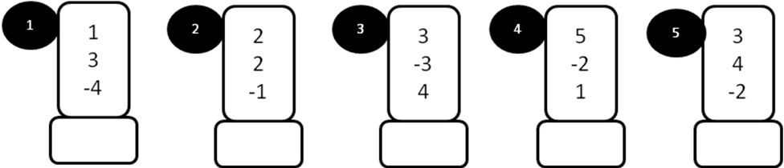
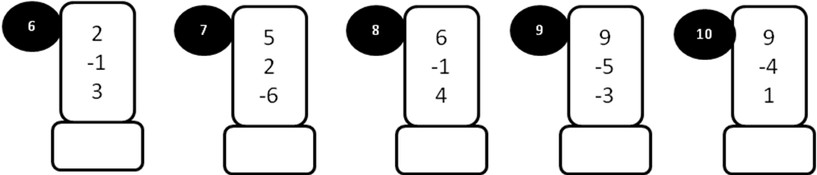
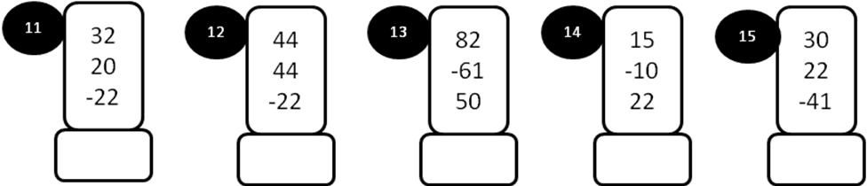
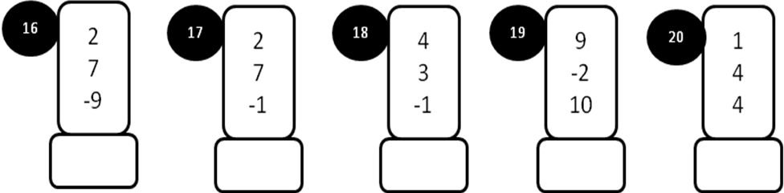
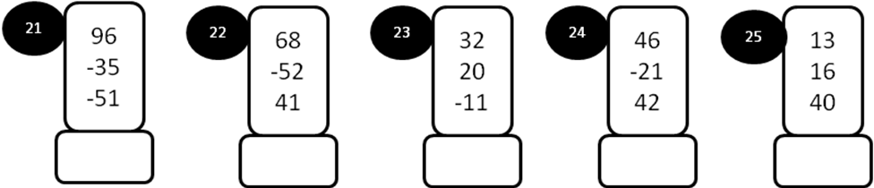
MODEL PAPER =II

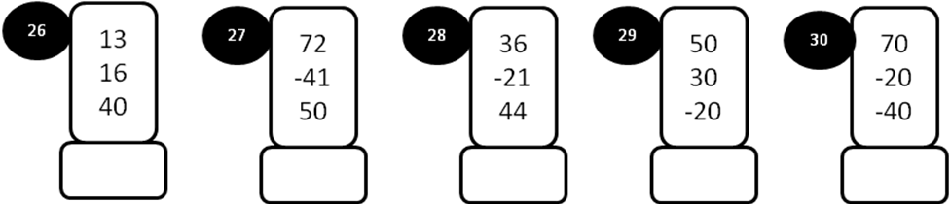
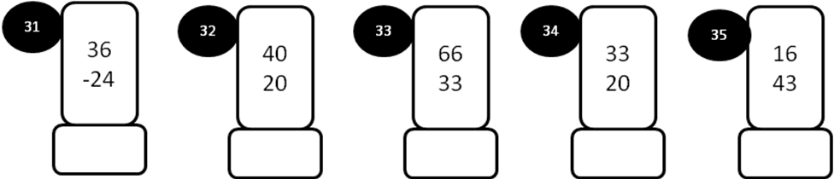
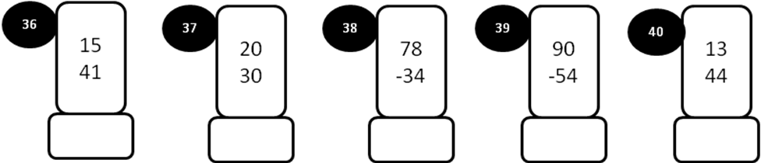
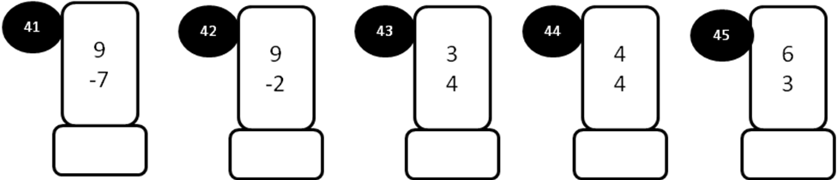
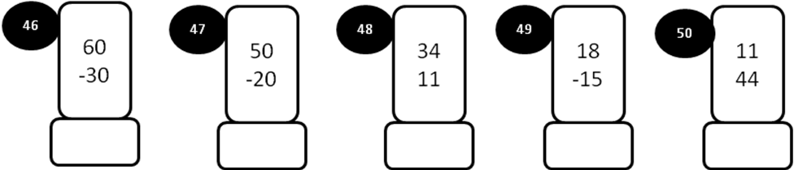

MODEL PAPER=III

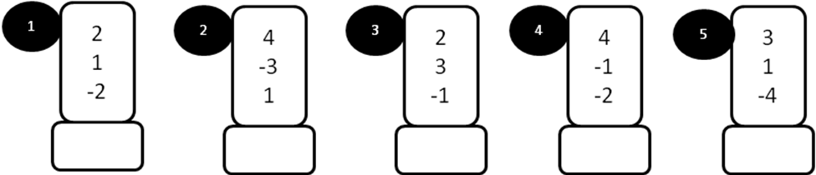
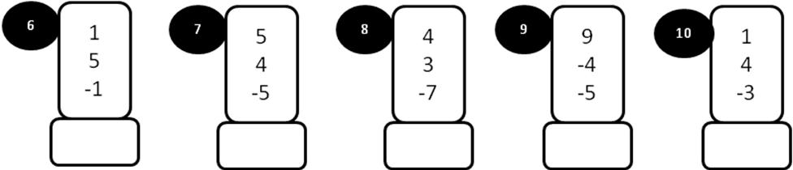
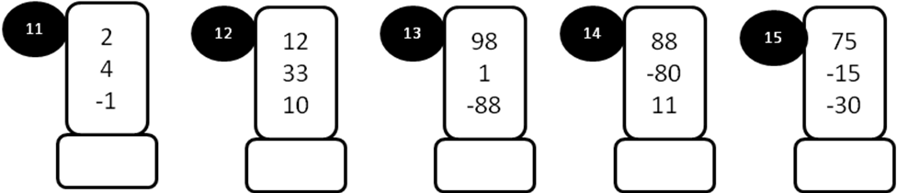
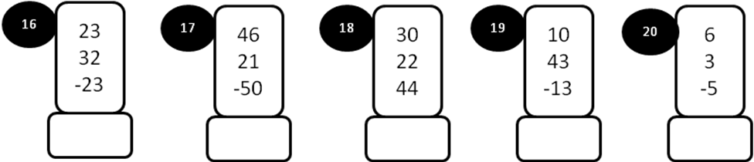
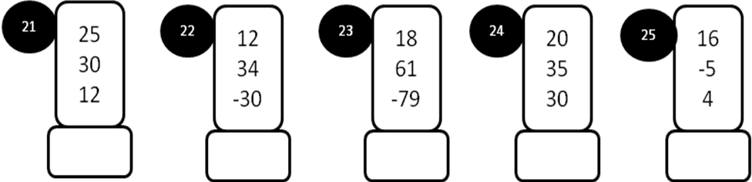

MODEL PAPER=III

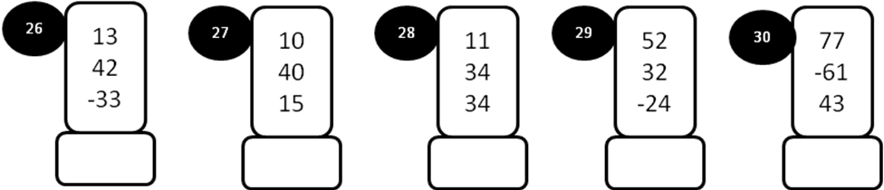
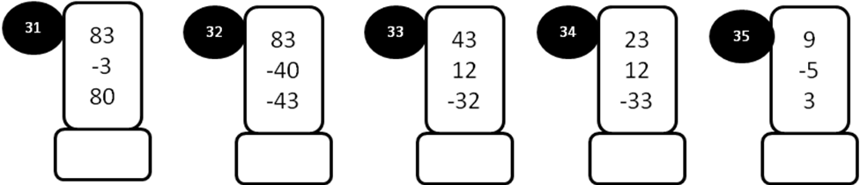
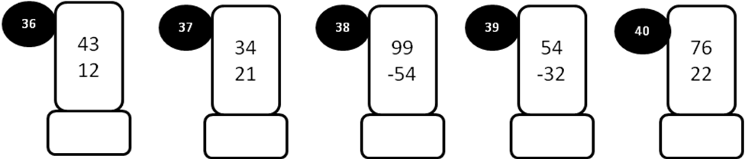
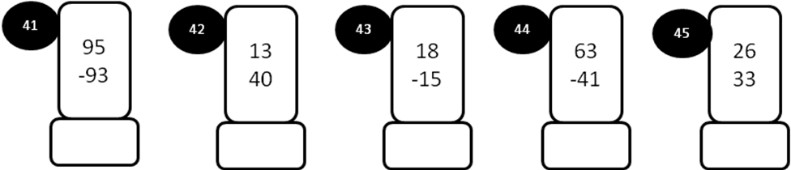
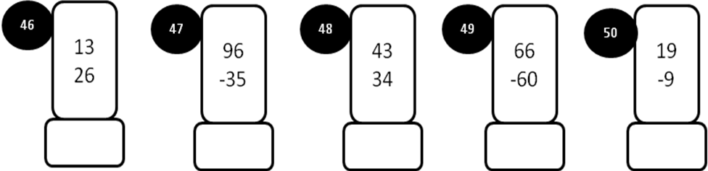

MODEL PAPER=IV
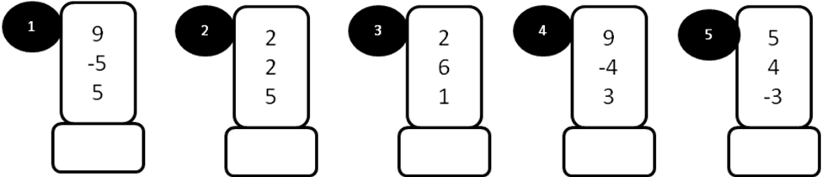
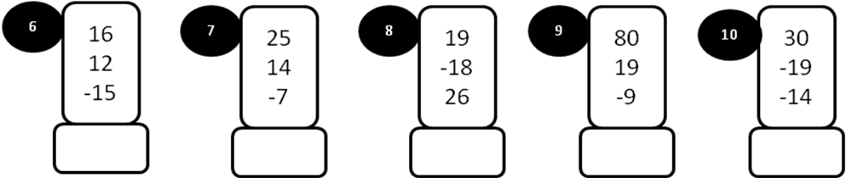
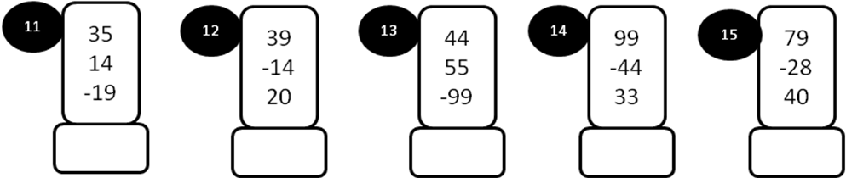
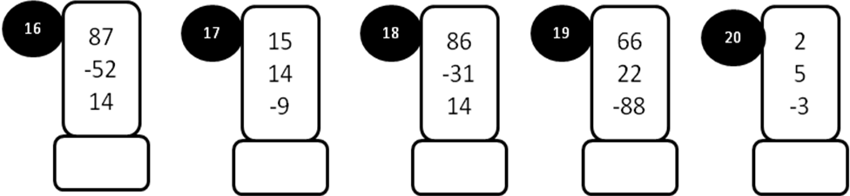
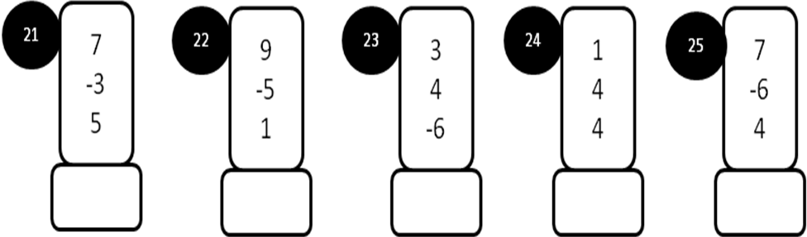
MODEL PAPER=IV
