MODEL PAPER=I

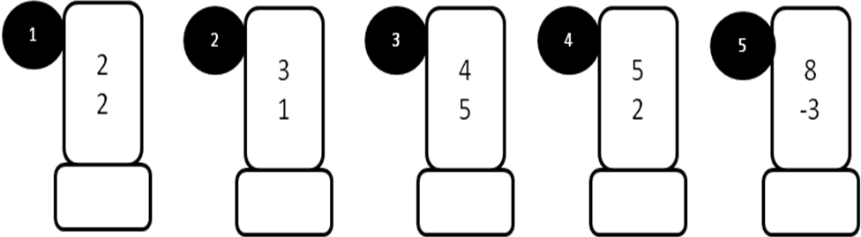
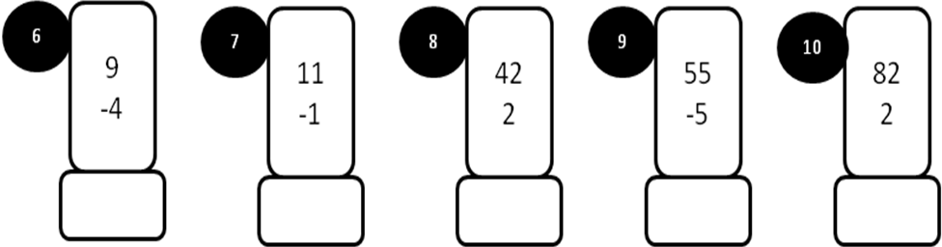
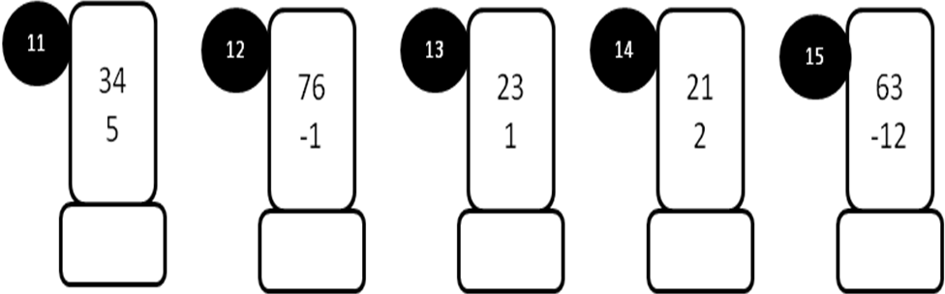
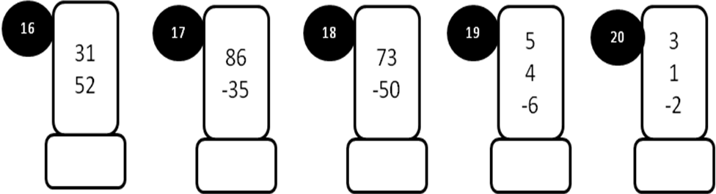
MODEL PAPER=I

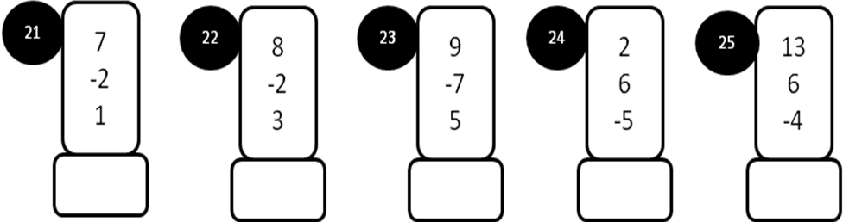
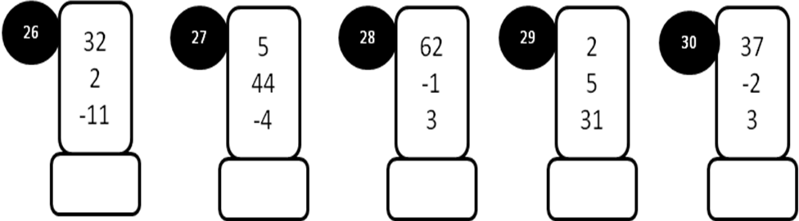
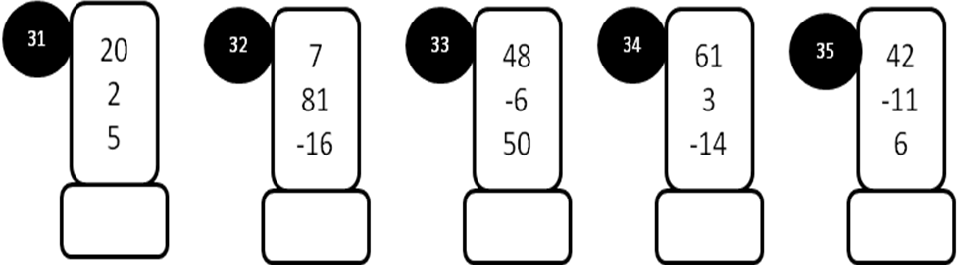
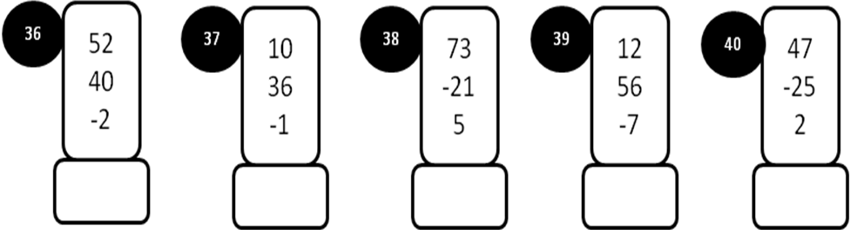

MODEL PAPER=II
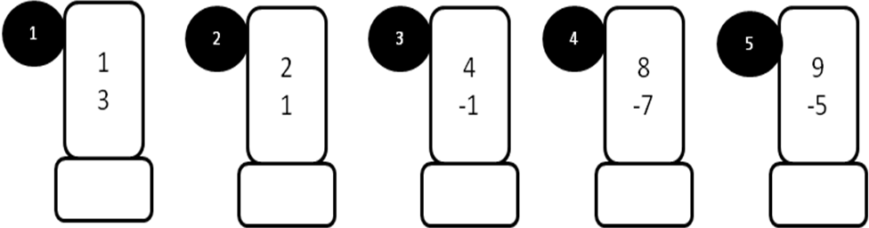

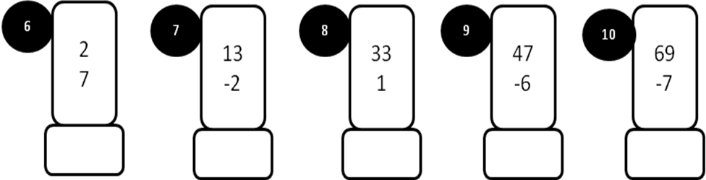

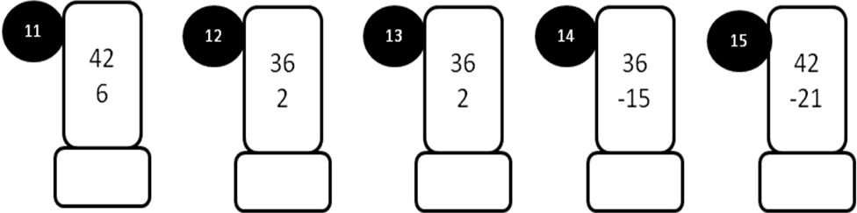

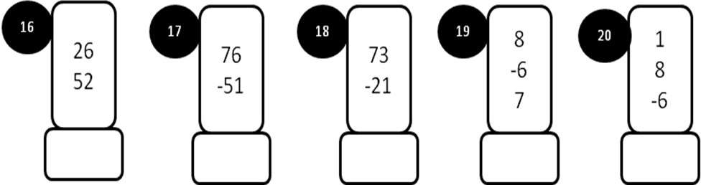
MODEL PAPER=II

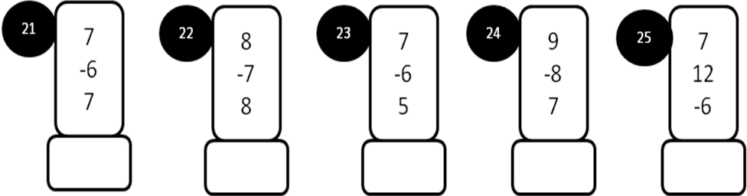
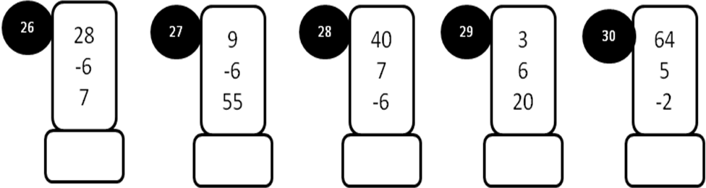
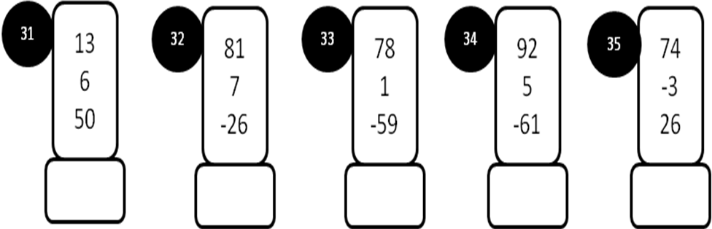
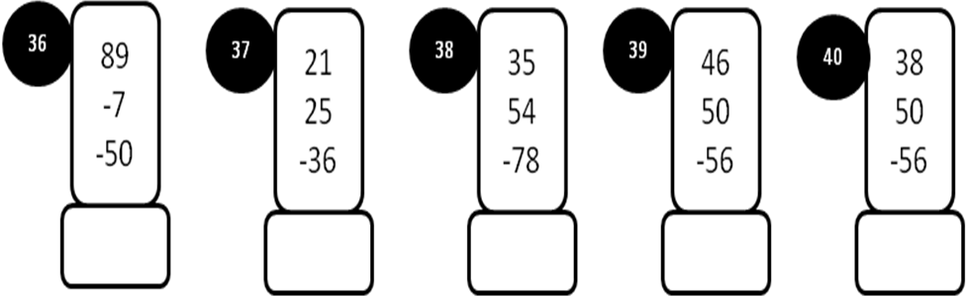
MODEL PAPER=III

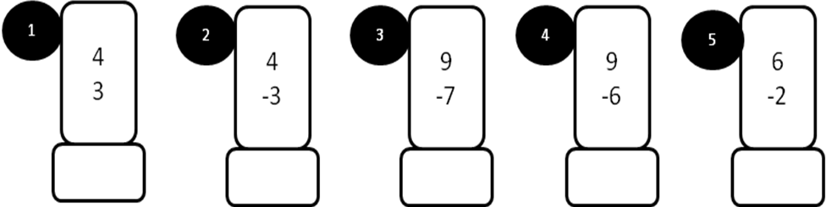
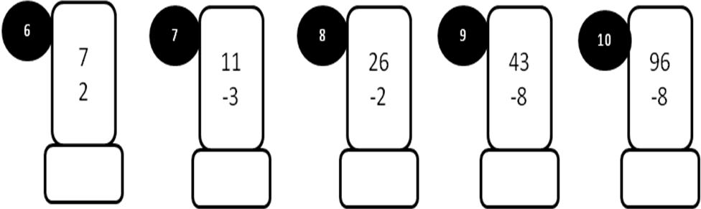
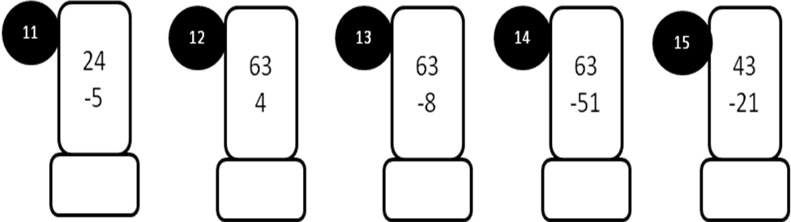
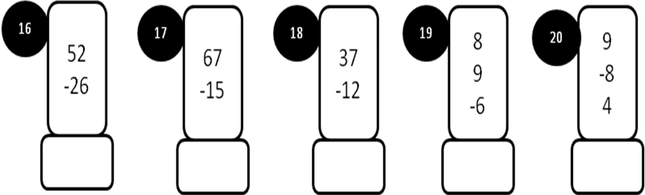
MODEL PAPER=III
